Master Thesis

**How to Distribute New Solar Systems in Europe to Reduce Power Generation Variability**

Department Environmental Systems Science / Earth Sciences, ETH Zürich

Institute for Atmospheric and Climate Science

Supervisors:

Dr. Jan Wohland, Institute for Environmental Decisions, ETH Zürich

Dr. Doris Sylvia Folini, Institute for Atmospheric and Climate Science, ETH Zürich

Dr. Stefan Pfenninger, Institute for Environmental Decisions, ETH Zürich

Prof. Dr. Martin Wild, Institute for Atmospheric and Climate Science, ETH Zürich

Submitted by

Dirk Mühlemann

13-732-037

Uster, 01/05/2021

Abstract

To reduce greenhouse gas emissions and combat climate change, the electrical power production sector faces a fundamental transition from conventional fossil to renewable technologies. The growth has already started, which can be seen by the tremendous effort and ambitious targets of many nations worldwide. Installed power production capacities of solar photovoltaics (PV) are increasing every year and can produce around 5.5% of the European electricity demand. Since PV power production depends on weather and climate, it exhibits a highly variable production pattern. This variability challenges the electricity grids because the grids' stability depends on balanced supply and demand. Further massive deployment of PV systems could lead to an increase in the variability and therefore add to this challenge.

This study identifies spatial distributions of newly installed PV systems that minimize the multiday power output variability in Europe. To quantify the variability, we perform empirical orthogonal function (EOF) analyses of geopotential height at 500hPa, reflecting weather regimes and therefore has an indirect effect on the PV power production. The geopotential height field is taken from the ERA5 reanalysis dataset, which covers 1979 to the present. The resulting subspace spanned by the leading 16 EOFs (explains ~90% of the variance) of our analysis is grouped in seven different weather regimes with the k-mean clustering techniques. The resulting weather regimes are linked to country-specific PV capacity factors to assess the PV power production variability. We use hourly PV capacity factors provided by the simulation of renewable.ninja from 1985-2016. Connecting the regimes with PV capacity factors leads to an overview of under- and overproduction (relative to the mean) per country and weather regime. The current and planned (2030 and 2050) installed capacity of PV systems in Europe is used together with our findings to assess the current and future multiday PV power production variability in Europe. Furthermore, we numerically find an optimal (linear least-square fit) distribution of additional installed PV capacities, minimising the multiday variability.

The mean PV power production variability, which is the average change of PV power production from one weather regime to another, currently (2019) amounts to 0.9 GW. Whereas the current maximum variability, which is the change of PV power production from the weather regime with the highest PV production to the one with the lowest production, amounts to 3.0 GW. We estimate that with the planed installed PV capacity distribution, the variability is expected to triple by 2030 to 2.7GW and 8.5GW, respectively. Estimates for the year 2050 emphasise that the mean variability could increase from 6.4 GW up to 63.2 GW (depending on the scenario). The maximum variability could even increase from 20.1 GW to 198.6 GW. We could show that reducing the variability for different scenarios of future installed PV capacity distribution is possible. Our method reduced the mean variability by up to 44.4 % and the maximum variability up to 38.8 %. The variability reduction could be achieved by mainly placing the new installed PV capacity to South-eastern and North-western Europe.

Contents

1. Introduction 5

2. Data & Methods 8

2.1 Data 8

2.1.1 ERA5 8

2.1.2 Renewables.ninja and the Global Solar Energy Estimator (GSEE) 8

2.1.3 Installed PV capacities 11

2.1.4 Electricity consumption data 12

2.2 Method 14

2.2.1 WR classification based on geopotential height of ERA5 15

2.2.2 Capacity factors and PV power production variability 17

2.2.3 Variability reduction with optimal IC distribution 18

2.2.4 Scenarios 19

3. Results 22

3.1 Weather regimes and their linked capacity factor anomalies 23

3.1.1 Weather regime 0 / NAO+ 27

3.1.2 Weather regime 1 - European trough 27

3.1.3 Weather regime 2 – NAO- 28

3.1.4 Weather regime 3 - Atlantic ridge 28

3.1.5 Weather regime 4 - Atlantic trough 28

3.1.6 Weather regime 5 - European blocking 29

3.1.7 Weather regime 6 - Scandinavian blocking 29

3.1.8 No regime 29

3.2 Installed capacity distributions and their variability 31

3.2.1 Scenario 1 (S1) – PV power production and installed capacities from NECP 2030 32

3.2.2 Scenario 2 (S2) – PV IC in 2050 37

3.2.3 Scenario 3 (S3) – Cost minimization 40

3.2.4 Scenario 4 (S4) –Coverage of country-specific electricity consumption with PV systems 41

4. Discussion 46

4.1 Weather regimes classification 46

4.2 Capacity factor anomalies and surface weather variables 47

4.3 Current and projected PV power production variability 49

4.4 Variability reduction potential 51

4.4.1 S1 - PV power production and installed capacities from NECP 2030 52

4.4.2 S2 - PV IC in 2050 53

4.4.3 S3 - Cost minimization 54

4.4.4 S4 - Coverage of country-specific electricity consumption with PV systems 37 54

5. Conclusion 57

6. Appendix 59

7. References 68

# Introduction

Many governments undertake ambitious climate mitigation efforts to reduce the adverse effect of global warming and thereby try to meet the 1.5°C goal from the Paris agreement (Hulme, 2016). A transition from conventional fossil to renewable energy technologies is substantial to achieve this goal. Solar power generating photovoltaic (PV) systems, as one of the major renewable technologies, has seen tremendous growth in recent years. According to the PV status report (2019) by the European Commission, there was a global installed capacity of 520GW by the end of 2018. By the end of 2019, the installed capacity is expected to reach 650 GW, which allows the PV systems to produce roughly 4% of the global electricity demand. Europe's share of installed PV capacity at the end of 2018 was about 117 GW, producing 5.5% of Europeans electricity demand.

Furthermore, current scenarios for the necessary installed PV capacity if the world is to reach 100 % renewable electricity production in 2050 suggest that the PV installed capacity must rise to more than 4 TW by 2025 and 21.9 TW by 2050. For Europe, this would imply a PV installed capacity of 630 GW by 2025 and 1.94 TW by 2050 (Jäger-Waldau, 2019). Current (2019) planning strategies by the Nation Energy and Climate Plans (NECPs) of the European Union (EU) suggest that the installed PV capacity will increase to XXX GW by 2030. This is far less than proposed by Jäger but still shows the intention to grow and the additional effort that is needed towards 2050.

Available surface solar radiation and panel temperature dominate the efficiency of a PV panel (Huld et al., 2010). Since these two variables are related to large-scale weather regimes (WR), the PV power production is subject to significant fluctuations. During one WR, the PV production pattern varies substantially to the next WR, which also applies to wind power production (Drücke et al., 2020; Graabak & Korpås, 2016; Stram, 2016). To operate a stable power grid, electric consumption must always equal electric production. If the production is higher than the consumption, the power grid frequency increases, which can cause damage to connected electrical devices. If the consumption is higher than the production, the frequency decreases, leading to power outages (Hirth & Ziegenhagen, 2015). The steady increase of wind and PV installed capacities requires accurate forecasting of renewable power production to balance the power grid. Therefore, the knowledge of WR and its impact on renewable production patterns is essential.

There are different approaches to classify WR. The most common is based on empirical orthogonal function analyses (EOF) and k-mean clustering with 500 hPa geopotential height anomalies (Cassou, 2008; Michelangeli et al., 1995). Different studies have used this approach to determine power production variability with renewable (wind and PV) energy technologies (Brayshaw et al., 2011; Ely et al., 2013; Grams et al., 2017; van der Wiel et al., 2019). Another approach is to include the renewable electricity production and electricity demand and the weather variables to define ‘Targeted Circulation Types’ that determine the WR in winter that influences the energy system the most (Bloomfield et al., 2020). Others expand the analysis to initially subjective defined 29 Grosswetterlagen developed by Baur et al. (1944) to assess the energy system's stress caused by renewable power production variability and electricity demand (Jones et al., 2020). The focus of current literature is mainly on wind power production in winter. This arises from the fact that wind power production variability is currently dominating over PV power production variability (Grams et al., 2017). Furthermore, the weather regime classification is usually done for winter, where the electricity demand is highest in Europe, which increases the stress for the energy system (van der Wiel et al., 2019). This has led to the four well-known weather regimes (positive and negative phase of the North Atlantic Oscillation, Scandinavian blocking, and Atlantic ridge). Their impact on the energy system is very well researched.

Fewer studies have tried to classify WR year around and to assess the renewable power production variability over the whole year (Grams et al., 2017). Also, projections to the future, especially for WR-driven PV power production variability and its possible impacts, are less well researched. With global warming, the electricity demand in Europe in summer increases because energy is used for cooling purposes (REF). Furthermore, wind turbines and solar systems' growth increases the stress for the energy system caused by variable power production patterns in all seasons. A year-round analysis with possible future scenarios is vital to fill this gap knowledge.

There is only one study to our knowledge investigating the potential of reducing renewable power production variability with an optimal distribution of wind fleets or PV systems within Europe based on weather regime classification. Grams *et al.* (2017) concluded that spatial deployment of wind fleets based on weather regime information could reduce the wind power production variability within Europe substantially. They also analysed the PV power production variability. Still, they did not further investigate it based on their findings that it would need a tenfold increase of installed PV capacity in Europe to be comparable to wind power production variability. Even though the decision to focus on wind rather than solar power output variability is comprehendible, calculations of necessary future installed PV capacities give reason to do the investigations anyway. Manish Ram et al. (2017) estimated that the installed PV capacity for a 100% renewable scenario in Europe must rise to 1.94 TW by 2050. The International Renewable Energy Agency (IRENA) estimated Europa’s share a bit lower to 0.89TW. This is roughly a ten to twentyfold increase of installed PV capacity than the 87.19GW installed PV capacity used in the study by Grams *et al.* (2017). Therefore, the impact of multiday PV power production variability caused by different WR could also become substantial, which makes the investigation of the optimal spatial deployment of future PV systems in Europe before further massive deployment of great interest. The results could support current planning activities and reduce future grid balancing problems. Furthermore, the distribution of wind fleets, which reduces the wind power production variability obtained by Grams *et al.* (2017), is not the result of a formal optimization. A more sophisticated method that formally finds a distribution of PV systems that reduces PV power production variability could easily be used/extended for wind power production variability.

This study aims to provide potential locations for new PV systems in Europe to reduce power production variability. The study region will be based on geographical coverage of the European network of transmission system operators for electricity (ENTSO-E), including 36 countries. We first focus on the current PV power production variability within Europe to achieve this goal. Second, a projection of the PV power production variability to the year 2030 is done by considering the current plans from the NECPs. To highlight where the variability could lead to, different scenarios for the year 2050 are analysed. Finally, we introduce a novel method that numerically finds a distribution of PV systems that reduces the power production variability. A key element of the method is the ease of expansion, including wind power production variability and other constraints that must be fulfilled.

# Data & Methods

Chapter 2 first describes the datasets which are the underlying sources of this study (section data). Afterwards, it illustrates how the datasets are used to achieve the objective of reducing PV power production variability in Europe in the section method.

## Data

### ERA5

The reanalyse dataset, [ERA5](https://cds.climate.copernicus.eu/cdsapp#!/dataset/reanalysis-era5-pressure-levels?tab=overview) (Hersbach et al., 2018), which the European Centre for Medium-Range Weather Forecasts (ECMWF) publishes, is used as the source for the weather regime definition. It provides atmospheric, land and oceanic variables from 1979 to the present with a temporal resolution of an hour. The grid of ERA5 has a horizontal spatial resolution of 0.28 degrees (~31km) and 37 pressure levels in the vertical. Detailed documentation about the ERA5 reanalyses dataset can be found on the ECMWF confluence web page (Hennermann & Yang, 2018).

We use the 500hPa geopotential height variable from ERA5 in the domain 80°W to 40°E, 30°N to 90°N, covering the North Atlantic and continental Europe. Geopotential height relates to low and high-pressure systems (cyclones/anticyclones), which can be related to weather and are thus commonly used for weather regime classification (Cassou, 2008; Grams et al., 2017; Michelangeli et al., 1995). The domain specification is reasonable for our meteorological field investigations since it captures the largescale circulation that affects Europe. The hourly dataset covers the time from 01.01.1979 until 31.05.2020, which yields 363’048 data points. Additionally, the [ERA5-Land](https://cds.climate.copernicus.eu/cdsapp#!/dataset/10.24381/cds.e2161bac?tab=overview) (Muñoz Sabater, 2019) hourly data from 01.01.1981 until 31.05.2020 are used to get an overview of 2m temperature and surface solar radiation of the classified weather regimes. It is explicitly designed for surface application and provides a more accurate dataset for this framework as ERA5. Especially over complex terrain (orography), the ERA5-Land adds value to the ERA5 surface field. Furthermore, ERA5-Land has a higher spatial resolution of 0.1 degrees (~9km) (Muñoz Sabater, 2019). We choose a slightly coarser resolution of 0.25 degrees, comparable to the 0.28 degrees of geopotential height.

### Renewables.ninja and the Global Solar Energy Estimator (GSEE)

Renewables.ninja ([www.renewables.ninja](http://www.renewables.ninja/)) is an interactive web platform that simulates hourly power production of wind and solar power plants worldwide. It uses the so-called Global Solar Energy Estimator (GSEE) to calculate the PV power production. The source code of GSEE is freely available on [GitHub](https://github.com/renewables-ninja/gsee), and a detailed description of the GSEE can be found in Pfenninger and Staffell (2016). The study by Huld *et al.* (2010) si the theoretical background of GSEE. The following variables are the key meteorological input parameters of this method to estimate the energy yield of PV modules:

1. Direct and diffuse irradiance at the PV panel
2. Panel temperature

Pfenninger and Staffell (2016) use three data sources to estimate these variables: The two reanalysis datasets of Modern-Era Retrospective analysis for Research and Applications (MERRA and MERRA-2) and the Surface Solar Radiation Data Set - Heliosat (SARAH). Figure 1 shows the general approach of GSEE, and the following paragraph further explains it.

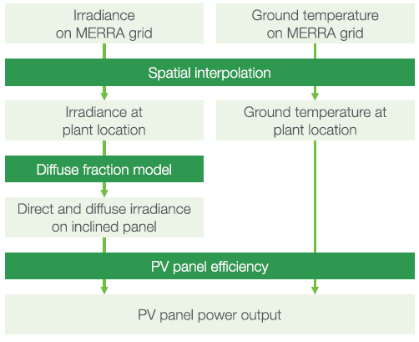

**Figure 1:** Overview of the approach used to model PV power production (Pfenninger & Staffell, 2016).

To get straight to the point: we use the dataset from renewables.ninja which is based on the reanalyse dataset MERRA-2. We hereafter describe the differences between the datasets and their advantages and disadvantages to justify our decision. Since the estimates with MERRA are no longer provided by renewables.ninja we will only discuss the two datasets MERRA-2 and SARAH. Both are provided in hourly intervals from 1985-2016. SARAH is a satellite-derived irradiance dataset with a high spatial resolution of 0.05° × 0.05° whereas MERRA-2 is a reanalysis dataset with a lower spatial resolution of 0.5° latitude and 0.625° longitude. MERRA-2 only provides direct irradiance, but diffuse irradiance is needed as well. Therefore, they use the Boland-Ridley-Lauret model to estimate the diffuse irradiance (Ridley *et al.* 2010; Lauret *et al.* 2013). Since SARAH provides direct and global irradiance no further estimates are needed.

Additionally, they use 2m temperature from MERRA-2 as estimates for the ambient temperature. To get the panel temperature, they use the ambient temperature of MERRA-2 and additionally consider the effect of the irradiance on the panel temperature. This relation was estimated with site measurements of one of their sources (DTI see below). This dataset provides ambient and panel temperature for each site with which they derived an empirical relationship.

It is more common and easier to compare and analyse PV power production with capacity factors than with absolute power production and we use this approach as well. It is also used by Pfenninger and Staffell (2016), which is why we introduce it already here to be able to discuss their results. The unit-less capacity factor CF is defined as:

|  |  |  |
| --- | --- | --- |
|  | $$CF=\frac{P}{IC}$$ | Eq. 1 |

where P is power production [W] and IC is the installed capacity [W]. The power production P is defined as the actual electricity output (in our case generated with PV systems) over a given time. The installed capacity IC is defined as the maximum possible electricity output (under optimal conditions) over that time. A CF of one is achieved when a PV system always produces electricity under optimal conditions during the time under review. A CF of zero indicates that no electricity is produced. The average yearly CF of PV systems in European countries are roughly between 0.1 and 0.2.

To evaluate the results obtained with the method described above, Pfenninger and Staffell (2016) compared it with capacity factors based on on-site measurements. To get the measured capacity factors, they used three sources: DTI, PVLog.de and PVOutput.org. Over 1000 site data (measurements from PV systems) were collected from these three sources. Figure 2 shows a histogram of the difference between measured capacity factors and capacity factors simulated with the GSEE.

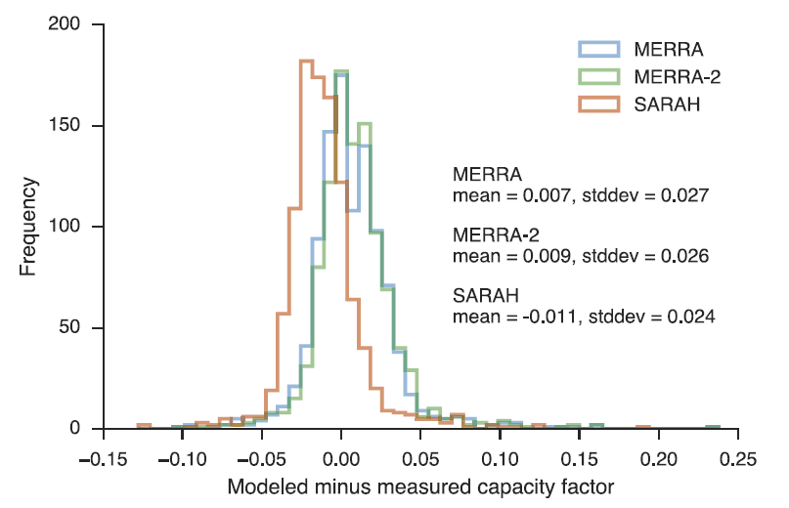**Figure 2**: Histogram of the difference between the three modelled and measured capacity factors. Negative values infer underestimates of the capacity factor and positive values infer overestimates. The blue graph corresponds to modelled data with MERRA, the green graph to MERRA-2 and the red graph to SARAH. (Pfenninger and Staffell, 2016)

Pfenninger and Staffell (2016) take the mean of these differences as the basis for a bias correction. They used it to calculate one correction factor for each simulation (MERRA-2 and SARAH).

Additionally to the power output simulation of a wind or solar plant at a specific location, renewables.ninja also provides capacity factors per country. Pfenninger and Staffell (2016) have performed randomized (tilt and azimuth angel) national-scale simulations with MERRA-2 and SARAH data to estimate averaged capacity factors per country. Also, these data were analysed against the measured site data. The measured capacity factor per country was then calculated as the mean of all capacity factors per site in one country.

This capacity factor per country suits perfect our need for analysing large-scale PV power production variability and its reduction potential.

Since our study focuses on reducing PV power production variability within Europe, we operate with relatively large-scale and long-term quantities. Therefore, we use the capacity factors per country derived with the reanalysis dataset MERRA-2. The reason to choose MERRA-2 rather than SARAH is its long-term consistency. According to Pfenninger and Staffell (2016), SARAH suffers from a significant amount of missing data. They stated that, especially before 1995, the lack of data prevents long-term consistency. SARAH's benefits would be the higher spatial resolution and higher precision in estimating the energy yield of PV panels on hourly to daily time scales, which is not crucial for our analysis. Nevertheless, a further advantage of this approach is to be in line with the study of Grams *et al.* (2017), which makes further comparison or combination analyses of wind and solar power output variability easier.

### Installed PV capacities

Data from the International Renewable Energy Agency (IRENA) are used to gather the current installed PV capacities (2019) for each country in Europe (Table 2). *“IRENA is an intergovernmental organisation that supports countries in their transition to a sustainable energy future, and serves as the principal platform for international co-operation, a centre of excellence, and a repository of policy, technology, resource and financial knowledge on renewable energy”* (IRENA, 2020b). With the capacity factors by renewables.ninja (section 2.1.2), each country's PV power production is calculated (Eq. 1). Furthermore, the estimates where we need to be in 2050 presented in the “Energy Transformation Roadmap to 2050” by IRENA are used as one source for the PV installed capacity in Europe 2050 (IRENA, 2020a). The other sources to estimate the needed PV IC in 2050 are the Energy Watch Group (Ram et al., 2017) and SolarPower Europe (SolarPower Europe and LUT University, 2020). An overview of the sources and their estimates can be found in Table 1:

Table Estimates of needed installed PV capacities for the year 2050.

|  |  |  |
| --- | --- | --- |
|  | Installed PV capacity 2050 [TW] | Comment / Scenario |
| SolarPower Europe  (SolarPower Europe and LUT University, 2020) | 4.7 – 8.8 | 4.7 TW in the Laggard scenario, 7.7 TW in the Moderate scenario and 8.8 TW in the Leadership scenario |
| IRENA  (IRENA, 2020a) | 0.891 | REmap Case |
| Energy Watch Group  (Ram et al., 2017) | 1.94 | 100% RES scenario of the Energy |

To further analyse where the PV power production variability is heading, the National Energy and Climate Plans (NECPs) of each country in the EU is used. Within the NECPs each country defines the number of PV systems they plan to install until 2030. For the rest of Europe, individual national plans are considered or, if not found, the average PV installed capacity growth rate until the year 2030 from all EU countries is multiply with the current PV installed capacity to get an estimate. An overview of the data used can be found in Table 2.

### Electricity consumption data

Electricity consumption data are taken from the open-power-system-data ([opsd](https://open-power-system-data.org/)). For countries that are missing in the opsd dataset, the European Union's statistical office ([Eurostat](https://ec.europa.eu/eurostat/databrowser/view/nrg_cb_e/default/table?lang=en)) is used as a source. Since the data availability per year differs per country, we take the latest fully reported year for each country as current total electricity consumption (range between 2016 and 2019).

Table : Overview of all considered countries with their installed PV capacity of 2019 (IRENA, 2020b), their planed installed PV capacity of 2030 from the National energy and climate plans and their mean capacity factors (1985-2016) from renewables.ninja.

|  |  |  |  |
| --- | --- | --- | --- |
|  | Installed PV capacity  2019 [MW] | Planed installed PV capacity  2030 [MW] | Mean PV capacity factor  1985-2016 |
| Albania | 3 | 9 | 0.16 |
| Austria | 1'578 | 2'500 | 0.14 |
| Bosnia and Herzegovina | 18 | 45 | 0.15 |
| Belgium | 4'531 | 15'000 | 0.12 |
| Bulgaria | 1'065 | 3'216 | 0.15 |
| Switzerland | 2'524 | 4'400 | 0.15 |
| Cyprus | 129 | 3'975 | 0.18 |
| Czechia | 2'070 | 3'975 | 0.13 |
| Germany | 48'960 | 98'000 | 0.12 |
| Denmark | 1'079 | 7'842 | 0.11 |
| Estonia | 107 | 415 | 0.11 |
| Spain | 8'761 | 39'200 | 0.17 |
| Finland | 215 | 700 | 0.09 |
| France | 10'562 | 44'000 | 0.14 |
| Greece | 2'763 | 7'700 | 0.16 |
| Croatia | 69 | 768 | 0.14 |
| Hungary | 1'277 | 6'454 | 0.14 |
| Ireland | 36 | 1'250 | 0.11 |
| Italy | 20'900 | 51'200 | 0.15 |
| Lithuania | 103 | 792 | 0.11 |
| Luxembourg | 150 | 1'000 | 0.13 |
| Latvia | 3 | 9 | 0.11 |
| Moldova | 4 | 12 | 0.14 |
| Montenegro | 3 | 9 | 0.16 |
| Macedonia | 26 | 77 | 0.15 |
| Malta | 154 | 266 | 0.17 |
| Netherlands | 6'725 | 27'000 | 0.12 |
| Norway | 90 | 265 | 0.10 |
| Poland | 300 | 7'300 | 0.12 |
| Portugal | 828 | 9'000 | 0.17 |
| Romania | 1'386 | 5'100 | 0.14 |
| Serbia | 10 | 25 | 0.15 |
| Sweden | 644 | 2'650 | 0.10 |
| Slovenia | 222 | 1'650 | 0.14 |
| Slovakia | 472 | 1'200 | 0.13 |
| United Kingdom | 13'398 | 39'478 | 0.11 |
| Sum | 131'165 | 386'481 |  |

## Method

Figure : Overview of the approach to derive the weather regimes, link the country-specific capacity factors and find a distribution that reduce the PV power production variability.

### WR classification based on geopotential height of ERA5

As the first step, we resample the hourly geopotential height fields from ERA5 by calculating daily means for each 2D grid point (Figure 3, step 2). Afterwards, a 10-day lowpass filter is applied because weather regimes are a low-frequency phenomenon and typically last several days. We apply the 10-day lowpass filter with the python package [scipy.signal.butter](https://docs.scipy.org/doc/scipy/reference/generated/scipy.signal.butter.html), which has implemented the Butterworth filter design. A filter order of two and a critical frequency of 0.1 (10-days) are used as the filter parameters (Figure 3, step 3). The lowpass filtered daily means ($z_{d}$) are used to calculate standardized anomalies (z_norm) which are the input data for the EOF analysis (see below):

|  |  |  |
| --- | --- | --- |
|  | $${z_norm}_{d} = \frac{z_{d}-z_{d,mean}}{z_{d,std}}$$ | Eq. 2 |

where zd are the lowpass filtered daily means of the geopotential height field, zd,mean are the climatological of the geopotential height daily means with a running window of 30 days, and zd,std are the standard deviations of the geopotential height daily means with a running window of 30 days. The running window is defined as the respective day acting as the centre of the window. For instance, to derive the reference climatology for the 15th of January the mean of the first to the 30th January is calculated for every year and grid point. This results in 41 means per grid point since our dataset covers 41 years. These 41 means per grid point are retaken to calculate a mean so that we finally have one reference climatology for the 15th of January for every grid point. This is done analogously for every day of the year, which yields 366 separate reference climatology and standard deviations.

Since the standardized anomalies include normalizing with the standard deviation, the amplitude in the anomaly caused by the seasonal cycle is removed before the weather regime classification. The removal of the anomaly caused by the season cycle clears the way to define the WR year around. The used 30-day running window for the reference climatology and standard deviation calculations differs from other studies. Often, investigations are only made for weather regime in winter where a correction for the seasonality is not needed (REF). Others (GRAMS) are using 90-day, but since our interest focus on multiday timescale, this is rather long and increases the probability that the impact of the signal of the seasonal cycle is relatively high.

For the weather regime classification (Figure 3, step 5 and 6), the well-known method of empirical orthogonal function analysis and k-means clustering is used (Cassou, 2008; Michelangeli et al., 1995). An EOF analysis decomposes a dataset into statistically orthogonal modes and corresponding time-series that describe the data's variability. For meteorological datasets, a few modes are often sufficient to explain a large fraction of the total variability in the data, which helps assess the key patterns of the variability and further analyse them. We perform the EOF analysis on the standardized anomalies with the eofs python package by Dawson (2016). The EOF analysis is performed with the square root of the cosine of latitude as weights to consider the grid point size change with latitude.

The resulting first 16 principal components of our EOF analyses, which explained ~90% of the variance, are used to cluster the data into weather regimes (Figure 3, step 6). We use the clustering method k-means implemented in the python package sklearn.cluster by Pedregosa *et al.* (2011). Generally, clustering techniques are used to group data with similar characteristics by minimizing the clusters' variance. The difficulty lies in the definition of the number of clusters. For the Euro-Atlantic region, often four clusters are used to define the weather regimes (Cassou, 2008; Michelangeli et al., 1995; van der Wiel et al., 2019). The well-studied four weather regimes which are received with this approach are the negative and positive phase of the North Atlantic Oscillation, the Scandinavia high and the Atlantic ridge (EVTL FIG). But most of these studies focus only on wintertime weather regime classification. According to Grams *et al.* (2017), the optimal number of clusters to define weather regime year around is seven, which seems plausible by a simple visual check with the elbow and silhouette method. Therefore, we use 7 clusters and make a comparison/combination with the study by Grams *et al.* (2017) easier. Furthermore, we sort all days out where a weather regime does not last at least three days and assign these days to a separate weather regime hereafter called “no-regime” (Figure 3, step 7). This is done by checking the time-series after the clustering and finding all days where a weather regime does not prevail for at least 3 subsequent days and assign it to “no-regime”.

To summarise, we use EOF analysis to decompose our dataset (standardized anomalies of geopotential height) and find the modes which explain the largest fraction of the variability. Afterwards, the EOF analysis results are used to cluster the data, which allows deriving an assignment for each day of the ERA5 dataset to one of 7 weather regimes.

### Capacity factors and PV power production variability

As a first step, the CF dataset is resampled to get daily means (Figure 3, step 9). Since the CF are highly influenced by the seasonal cycle, they are analysed separately for each season. The season is defined with the months December, January, February (DJF) for winter - March, April, May (MAM) for spring - July, June, August for summer and September, October, November for autumn. With the weather regime classification, the capacity factor can now be linked to the different weather regimes (Figure 3, step 10). The linked capacity factors are used to calculate mean capacity factors per weather regime, country, and season (${CF}_{wr,country,season}$). The difference between these mean capacity factors and the mean capacity factors for the whole season of a country (${CF}_{country,season}$) determines whether the weather regime's impact exhibits over- or underproduction (Eq. 3).

|  |  |  |
| --- | --- | --- |
|  | $${∆CF}_{wr,country,season}= {CF}_{wr,country,season}-{CF}_{country,season}$$ | Eq. 3 |

where CFwr,country,season is the mean capacity factor of a specific weather regime, country and season [unitless] and CFcountry,season is the mean capacity factor of a country for the whole season [unitless].

Multiplication of capacity factors with installed capacities yields power output (Eq. 1). This can be used to expand Eq. 3, which gives the total deviation of PV power production of Europe per weather regime and season (Figure 3, step 11).

|  |  |  |
| --- | --- | --- |
|  | $${∆P}_{wr,Europe,season}=\sum_{country}{\left({∆CF}_{wr,country,season}*{IC}_{country}\right)}$$ | Eq. 4 |

where ICcountry is the installed capacity per country [W] and ${∆CF}_{wr,country,season}$ is the deviation of CF per weather regime, country and season to the seasonal mean [unitless].

Eq. 4 is used as an expression for the variability and the basis to achieve the objective of reducing PV power production variability defined in the introduction of this study. Suppose the result of this equation is zero. In that case, the respective weather regime and season's PV power production is equal to the mean PV power production of the respective season. Therefore, the variability is maximally reduced. If the results for every WR and season of Eq. 4 are zero, the PV power production is constant throughout the year. That would imply that the variability is vanished, which massively reduces the challenge to consider the PV power production for power grid balancing purposes.

The consideration of seven weather regimes plus no regime and four seasons implies 32 results of Eq. 4 for the variability. To consolidate these 32 results, we introduce the mean PV power production variability and maximum PV power production variability. The mean PV power production variability is defined as the sum of the absolute changes in PV power production from one weather regime to another, weighted with the corresponding frequency of the change:

|  |  |  |
| --- | --- | --- |
|  |  | Eq. 5 |

where n is the total number of weather regimes, ${∆P}_{{wr}_{i},Europe,season}$ is the deviation of PV power production from the seasonal mean per weather regime, $f_{i,j}$ is the frequency of the transition from WR i to j. We calculate the frequency as the division of the number of transitions from weather regime i to j per season and the total number of transitions per season.

The maximum PV power production variability is defined as the difference of the weather regime with the highest PV power production (${∆P}_{{wr}_{max},Europe,season}$) and the weather regimes with the lowest PV power production ( ${∆P}_{{wr}_{min},Europe,season})$ per season:

|  |  |  |
| --- | --- | --- |
|  | $$max⁡_var={∆P}_{{wr}_{max},Europe,season}- {∆P}_{{wr}_{min},Europe,season}$$ | Eq. 6 |

Total mean and maximum PV power production variability is defined as the average of the obtained results from Eq. 5 and Eq. 6 over the whole season.

### Variability reduction with optimal installed PV capacity distribution

To determine an IC distribution that distinctive reduces the PV power generation variability, Eq. 4 for every country, season and weather regime is used in a linear least-square problem with an upper and lower bound on the variables (Figure 3, step 12). This is done with the [scipy.optimize.lsq_linear](https://docs.scipy.org/doc/scipy/reference/generated/scipy.optimize.lsq_linear.html) python package, which solves the following optimization problem:

|  |  |  |
| --- | --- | --- |
|  |  | Eq. 7 |

where A is the coefficient matrix, x is the solution found, b is the target vector, lb is the lower bound of the solution x and ub is the upper bound of the solution x.

The coefficient matrix A is defined with ${∆CF}_{wr,country,season}$ from Eq. 3:

|  |  |  |
| --- | --- | --- |
|  | $$A= \left(\begin{matrix}{∆CF}_{WR0,AL, winter} & ⋯ & {∆CF}_{WR0,SK,winter} \\ ⋮ & ⋱ & ⋮ \\ {∆CF}_{WRX,AL,autumn} & ⋯ & {∆CF}_{WRX,SK,autumn}\end{matrix}\right)$$ | Eq. 8 |

where the first element of the matrix ${∆CF}_{WR0,AL,winter}$ is the capacity factor anomaly of weather regime 0, in Albanian in winter. The columns of A are associated with the 36 different countries considered (Table 2), whereas the 8 weather regimes and 4 seasons translate into the 32 rows of A.

The target vector $\vec{b}$ is set to zero to reduce the variability within one weather regime and season as much as possible and therefore also reduces the variability from one weather regime to another:

|  |  |  |
| --- | --- | --- |
|  | $$\vec{b} =[0,…,0]$$ | Eq. 9 |

where $\vec{b}$ has the same length as the number of rows of matrix A.

The result of this method is the vector $\vec{x}$ which contains the IC for each country:

|  |  |  |
| --- | --- | --- |
|  | $$\vec{x} =[{IC}_{AL},…,{IC}_{SK}]$$ | Eq. 10 |

The method to perform the minimization is the Trust Region Reflective (TRF) algorithm (Branch et al., 1999).

The lower bound is always set to the current (2019) PV IC per country (unless something else is mentioned in the scenarios below). The upper bound is always set to the potential PV IC which is taken from the study by Tröndle et al. (2019).

### Scenarios

Besides reducing PV power production variability, we may demand a certain minimum power production on a European scale or a maximum on the installed PV capacity to control associated costs or a combination of the two, or yet other conditions. Below we elaborate on associated scenarios. Their constraints are added row/element-wise to the coefficient matrix A (Eq. 8) and the target vector $\vec{b}$ (Eq. 9). The newly added rows and elements act as additional equations within our linear least-square problem, and their residuals are consequently also minimized. But first, we turn again to the associated equations and the question of weighting.

To meet the requirements of the different scenarios described below and get better control over our linear least-square problem, we introduce a weighting vector $\vec{w}$:

|  |  |  |
| --- | --- | --- |
|  | $$\vec{w} =[w_{0}, …, w_{x}]$$ | Eq. 11 |

where the elements of the vector $\vec{w}$ are the weightings for each of our equations defined with the coefficient matrix A and the target vector $\vec{b}$. The weighting vector is also useful to consider the various orders of magnitudes of our equations. I.e., the first 32 rows are of the same order of magnitude because they all describe the PV power production variability. But this is not the case if we introduce an equation/row which constrains our system to a minimum total European PV power production. Additionally, it must be considered that the method used to solve the linear least-square problem minimizes the sum of the residuals of the equations. Since our first 32 equations are all about variability, they are already relatively highly weighted compared to one equation we add with the same order of magnitude. With the introduced weighting vector, it is possible to counteract and give more weight to the one added equation if necessary.

To apply the weighting vector to the linear least-square problem, the square root of its elements is taken as elements of a diagonal matrix and multiplied with the coefficient matrix A and the target vector $\vec{b}$ before the optimization problem is solved.

|  |  |  |
| --- | --- | --- |
|  | $$A_{w}= A∙\left(\begin{matrix}\sqrt{w_{0}} & ⋯ & 0 \\ ⋮ & ⋱ & ⋮ \\ 0 & ⋯ & \sqrt{w_{x}}\end{matrix}\right)$$ | Eq. 12 |

|  |  |  |
| --- | --- | --- |
|  |  | Eq. 13 |

In the following, we introduce different scenarios for capacity allocation in the future.

#### Scenario 1 (S1) – PV power production and installed capacities from NECPs 2030

The objective of scenario S1 is to minimize the PV power production variability while the total power production with PV systems in Europe must remain the same (+/- 1GW) as in the scenario where NECPs for 2030 are fulfilled. This gives a direct comparison of the variability estimated with the plans of the countries in Europe for 2030 to the variability estimated with an optimal distribution of installed PV capacities that produces the same amount of electricity.

To realize S1, one row and element are added to the coefficient matrix A and the target vector $\vec{b}$, respectively. PV power production is calculated by multiplying IC with the CF (Eq. 1). Therefore, we add all the mean CF per country as a row to the coefficient matrix A. The total PV power production is added to the target $\vec{b}$. It is calculated as sum of the CF per country multiplied by the planned IC per country for 2030.

|  |  |  |
| --- | --- | --- |
|  | $$A_{S1}= \left(\begin{matrix}⋯ & ⋯ & ⋯ \\ ⋮ & ⋱ & ⋮ \\ {CF}_{AL} & … & {CF}_{SK}\end{matrix}\right)$$ | Eq. 14 |

where $A_{S1}$ is the coefficient matrix for S1 (expansion of Eq. 8) and ${CF}_{AL}$ and ${CF}_{SK}$ are the mean capacity factors for Albania and Slovakia which represents the mean CF for all countries.

|  |  |  |
| --- | --- | --- |
|  | $$\vec{b_S1} =[…, {tot}_{production_{2030}}]$$ | Eq. 15 |

where $b_S1$ is the target vector for S1 (expansion of Eq. 9), ${tot}_{IC_2030}$ is the total installed capacity planned for 2030 and ${tot}_{production_2030}$ is the total PV power production estimated with the planned IC 2030.

The weighting vector for S1 is chosen such that all equations considering the variability are set to one. The weighting of the equation that considers the total PV production is set to 10, whereas the weighting of the equations for the variability is set to one.

#### Scenario 2 (S2) – PV IC in 2050

In the scenario, S2 estimates of installed PV capacities for the year 2050 are taken to calculate the corresponding PV power production and use it as an additional equation in our linear least-square problem. Similar to S1, it is achieved by adding a row with all the mean CF per country to the coefficient matrix A and the total PV power production estimates for 2050 as an element to the target vector $\vec{b}$. Table 1, page 13 shows the used estimates by three different sources for the needed installed PV capacities in the year 2050.

S2 is calculated three times, first with the lowest value from Table 1 estimated by IRENA with 0.891 TW (S2-1), second with the middle estimate by the Energy Watch Group with 1.94TW (S2-2) and third with the highest estimate by SolarPower Europe in their Leadership scenario with 8.8 TW. The weighting vector for S1 is chosen such that all equations considering variability are set to one and the equation for the total PV power production is set to 10.

To set the results into context the variability is also calculated with the same amount of installed PV capacity but percentual equally distributed to the countries as it was in the year 2019.

#### Scenario 3 (S3) – Cost minimization

Additionally to the PV power production variability reduction, S3 focuses on minimizing the costs. This is done by minimizing the amount of installed PV capacity with the constraint that they must produce the same amount of electricity as estimated with the installed PV capacity planed in the NECPs for 2030 (S3-1) or with the estimates of 1.94 TW installed PV capacity by the Energy Watch Group (S3-2). The constraint for the PV power production is added similar as in S1. The consideration of minimal installed PV capacities is achieved by adding a row with ones to the coefficient matrix A and zero as an element to the target vector $\vec{b}$. This equation sets the total installed PV capacity to zero and therefore every added installed PV capacity per country acts as residual of this equation. This residual is minimized by our method together with the residuals for the variability and the PV power production.

The weighting vector for S3 is chosen such that all the equations which consider the variability are set to one. The weighting of the equation considers for the total IC are set to 0.1 and the equation which considers the total PV production is set to 10.

#### Scenario 4 (S4) – Coverage of country-specific electricity consumption with PV systems

The objective of scenario S4-1 is to minimize the PV power production variability, while each country must generate 10% of its electricity consumption with PV systems itself in the year 2030. The latest (between 2016 and 2019) available yearly electricity consumption data (section 2.1.4) is taken as a source for this purpose. Projections of electricity consumption for the year 2030 are neglected because the focus is on what happens with the variability if we enforce a flatter distribution of the installed PV capacities rather than on actual percentual coverages of the consumption per country. S4-1 is constructed like S1 but instead of the current installed PV capacities for each country as lower bound, S4 uses 10% of the yearly consumption per country divided by the CF per country as lower bound.

|  |  |  |
| --- | --- | --- |
|  | $${lb}_{country}=10\% ×\frac{{load}_{country}}{{CF}_{country}*365d*24\frac{h}{d}}$$ | Eq. 16 |

where ${lb}_{country}$ is the lower bound for the installed PV capacity per country [W], ${load}_{country}$ is the yearly electricity consumption per country [Wh] and ${CF}_{country}$ is the capacity factor per country [unitless].

To further analyse S4 it is run a second time for the year 2050 with the estimates of 1.94 TW installed PV capacity by the Energy Watch Group (S4-2). The same consumption data as in S4-1 are used but the coverage of the electricity consumption with PV systems is set to 30%.

# Results

Chapter 3 gives an overview of the obtained results. First, it describes the derived weather regimes and the linked capacity factors anomalies per country and season. Second, the results of the scenarios and their installed PV capacity distributions and variability are presented. Overall, we find that both, existing as well as planned, installed PV capacity distributions lead to large variability in PV power production depending on the weather regime. We present alternative spatial distributions of installed PV capacity that substantially reduce this variability while respecting selected additional constraints. The latter include total PV power production but also constraints like cost minimization (least possible installed PV capacity) or local PV power production.

## Weather regimes and their linked capacity factor anomalies

Figure 3 gives an overview of the derived weather regimes and their relation to the two most important input variables for GSEE. Namely the surface solar radiation and the 2m temperature. In Figure 3a) the weather regimes are presented as standardized geopotential height anomalies (Eq. 2) and their frequency of occurrence. Surface solar radiation and 2m temperature are also presented as standardized anomalies in Figure 3b) and Figure 3c) respectively. A standardized anomaly of 0.5 means that the difference of the weather regime average and the climatological 30-day running mean amounting to 50% of the 30-day climatological standard deviation. From Figure 3 it can already be taken that both weather variables show distinct, WR-specific patterns, which are discussed in more detail below An overview of the WR frequency can be found in Figure 5 and Appendix Table 7, illustrating that some WRs preferentially occur in some seasons. For instance, WR0, WR2, WR3, and WR5 are the dominating weather regimes in winter whereas WR1, WR3, WR4, and WR5 are dominating in summer. The relation between the weather regime number and the ordinary names, which are often used in literature, can be found in Table 3.

The link between the weather regimes and the derived capacity factor anomalies is shown in Figure 4. The first row of Figure 4 shows again the seven weather regimes plus no regimes. Beneath the weather regimes, in the same column, the corresponding country-specific capacity factor anomalies can be found. The different seasons are shown separately, and they are defined as winter (December, January, February 🡪 DJF), spring (March, April, May 🡪 MAM), summer (June, July, August 🡪 JJA), autumn (September, October, November 🡪 SON). The capacity factor anomalies are calculated as the difference to the corresponding seasonal mean. There are several reasons to treat the CF anomalies separately per season. One of them is the different seasonal cycle of wind (highest in winter) and PV power production (highest in summer) and their combination possibilities to balance the power grid. Another is the difference in electricity consumption per season and combined with the production, its risk for the energy system. Again, it is obvious from just looking at the figure that WRs play a decisive role in country-specific capacity factors. A detailed discussion is given below.

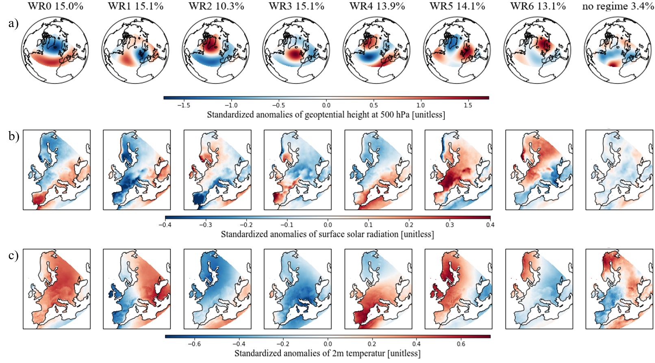

Figure : Different variables of the derived seven weather regimes and no regime plus their frequency of occurrence. a) Standardized anomaly fields of geopotential height at 500 hPa. b) Standardized anomaly fields of surface solar radiation. c) Standardized anomaly fields of 2m temperature.

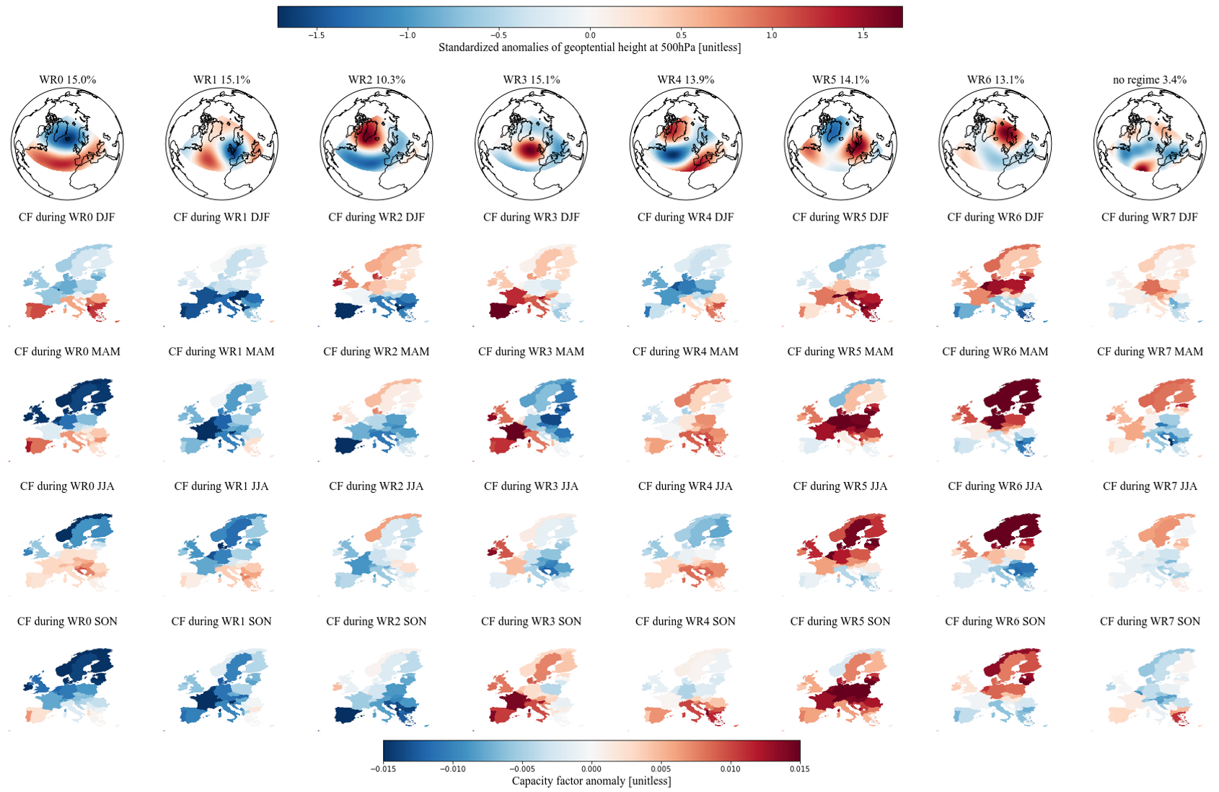

Figure : Link between the derived seven weather regimes (WR) and the capacity factor (CF) anomalies per country and season. The first row shows standardized anomaly fields of geopotential height at 500 hPa for each weather regime. The linked capacity factor anomalies per country are shown separately for each season and are calculated as difference to the corresponding seasonal mean: Winter (DJF), spring (MAM), summer (JJA) and autumn (SON).

Table : Relation between weather regime numbers and ordinary weather regime names.

|  |  |
| --- | --- |
| WR0 | The positive phase of the North Atlantic Oscillation (NAO+) |
| WR1 | European trough |
| WR2 | The negative phase of the North Atlantic Oscillation (NAO-) |
| WR3 | Atlantic ridge |
| WR4 | Atlantic trough |
| WR5 | European blocking |
| WR6 | Scandinavian blocking |

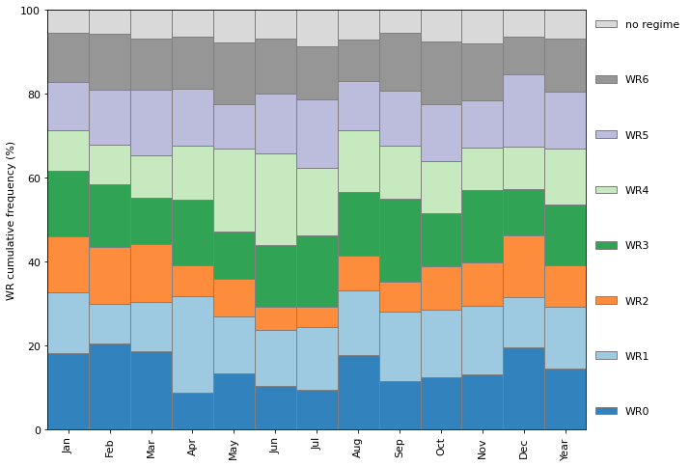

Figure : Cumulative frequency of the seven weather regimes (WR) and no regime.

### Weather regime 0 / NAO+

A negative geopotential height anomaly (cyclone) over the Northern part of the Atlantic and a positive geopotential height anomaly (anticyclone) over the Atlantic/Mediterranean sector is the characterizing feature of the positive phase of the NAO (WR0). During these conditions, the Atlantic storm tracks are displaced North-eastward, and the zonal flow is enhanced. This increases the strength of the westerlies and brings maritime air (warm and moist) to Central and Northern Europe (Hurrell et al., 2003; Rogers, 1997; Wallace & Hobbs, 2006). Consequently, the storm track activity over Northern Europe is enhanced, which implies a larger cloud clover fraction and therefore less available surface solar radiation. Studies by Pozo-Vázquez *et al.* (2004; 2011) indeed have shown that that the NAO index is negatively correlated with the surface solar radiation in Northern Europe and positively correlated with surface solar radiation in southern Europe. Our results agree with these studies with negative surface solar radiation anomalies in Northern Europe, positive surface solar radiation in Southern Europe and positive temperature anomalies almost all over Europe (Figure 3b) and c), the first column).

The CF anomalies during the positive phase of the NAO also exhibit a clear North to South discrepancy. Northern Europe shows negative CF anomalies whereas Southern Europe is dominated by positive CF anomalies. This is in line with the surface solar radiation described above but the pattern changes throughout the season. I.e., in spring (MAM) the results show a strong and clear difference between Southern and Northern Europe. But in autumn (SON) only the Iberian Peninsula and a few Countries in South-eastern Europe exhibit positive CF anomalies. WR0 is more frequent during winter times which may explain the change of the limpidity in the discrepancy (Figure 5).

### Weather regime 1 - European trough

WR1, the European through, is characterized by a meridional dipole of a positive and negative geopotential height anomaly in the Atlantic and Western Europe, respectively. The cyclone located over Western Europe brings relatively warm air from the South to South-eastern Europe and higher temperature than normal can be observed (Figure 3c), WR1). Surface solar radiation anomalies are also enhanced in South-eastern Europe but are not as pronounced. Western Europe, where the cyclone is located, shows negative temperature and surface solar radiation anomalies except the Northern part of the British Isles and the Western coast of Norway, which is already on the northern edge of the cyclone.

The CF anomalies during the European trough are mostly negative which agrees with the overall pattern of the surface solar radiation. But it does not fit in winter where Southern and South-eastern Europe exhibit an even larger negative impact than Northern Europe whereas the surface solar radiation for the whole year is positive for this region. Interestingly, this weakens in spring even turns to positive CF anomalies in summer which is more in line with our surface solar radiation anomalies presented year around. This may be caused because WR1 is less frequent in winter than summer and spring (Figure 5).

### Weather regime 2 – NAO-

Contrary geopotential height anomaly fields to the positive phase of the NAO can be found in the negative phase of the NAO (WR2). It is characterized by a negative geopotential height anomaly over the Atlantic/Mediterranean sector and a positive geopotential height anomaly over Greenland. This also results in contrary surface weather variables than for the positive phase of the NAO. More available surface solar radiation than the climatological average in Northern Europe and lower surface solar radiation in Southern Europe. The temperature anomalies are negative all over Europe.

The contrary pattern to the positive NAO is also reflected in the CF anomalies with positive values in Northern Europe and negative values in the South. But we can see here as well that this discrepancy between North and South is clear in winter and spring but weakens in summer and autumn where more negative CF anomalies are present in Northern regions. Again, the cause may lie in the more frequent occurrence of WR2 during winter times (Figure 5).

### Weather regime 3 - Atlantic ridge

The Atlantic ridge (WR3) exhibits a strong positive geopotential height anomaly (anticyclone) over the Atlantic. Enhanced surface solar radiation anomalies can be seen in Western Europe, mainly over the Iberian Peninsula and over Southern Scandinavia. These regions are located at the western edge of the anticyclone. This could explain the enhanced surface solar radiation because of the relation between anticyclones and descending air and therefore clear sky conditions. Eastern Europe, which is already outside the region of the anticyclone, shows negative surface solar radiation. The anticyclone brings relatively cold air from the North to Europe and therefore one can observe negative temperature anomalies all over Europe except the Western coast of the Iberian Peninsula and the British Isles.

The East-West gradient is also visible in the CF anomalies. With positive anomalies in the West and negative anomalies in the East. But the seasonal differences are substantial. In spring (MAM) one can observe a strong East-West gradient. In winter (DJF) and autumn (SON) one can still see a discrepancy between East and West but the anomalies are less pronounced and generally more often positive. The opposite is the case for summer where one can see more often but less enhanced negative anomalies but still with an East-West gradient.

### Weather regime 4 - Atlantic trough

WR4, the Atlantic, trough, shows a meridional dipole pattern of the geopotential height anomaly reversed to WR1. But the cyclone and anticyclone are more elongated in the meridional direction. The negative anomaly is located over the Atlantic and Northern Europe and the positive anomaly is located over the Mediterranean sector. It can be best compared with the Atlantic trough weather regime (i.e. GRAMS) but the positive geopotential height anomaly over South-eastern Europe does not fit well to this association. WR4 exhibits positive temperature anomalies over Southern and Central Europe in the region of the positive geopotential height anomaly and slightly negative temperature anomalies over Scandinavia. The surface solar radiation anomalies show a clear gradient from South-Eastern to North-Western Europe. Positive values are located over the Mediterranean region and negative values anomalies over Scandinavia and the British Isles.

The CF anomalies of the countries in the Mediterranean region resemble the surface solar radiation anomalies and show mostly slightly positive values. In Northern Europe, the difference between seasons is more pronounced. In winter and summer, they are negative but in autumn and especially in spring more Northern countries exhibit positive CF anomalies.

### Weather regime 5 - European blocking

The blocking situation in WR5 is characterized by a positive geopotential height anomaly (anticyclone) over Central Europe. This is associated with descending air which brings clear skies over central Europe and therefore enhanced surface solar radiation anomalies can be observed in Figure 3b, WR5. Only in the Scandinavian region and in Eastern Spain it is less pronounce or even negative because these regions are already on the edge of the anticyclone. The temperature is also enhanced especially in North-Western Europe which is the region where the anticyclone brings warm air from the South northwards.

With the clear sky condition, the CF are also higher than normal. Greatly increased CF anomalies can be observed especially in central Europe. In winter, the CF anomalies are only negative for Scandinavia and the British Isles. Towards summer these changes to positive CF anomalies whereas it changes for Southern countries to negative CF anomalies.

### Weather regime 6 - Scandinavian blocking

Like the European blocking the positive geopotential height anomaly (anticyclone) over Scandinavia relates to descending air, which results in clear sky condition and therefore enhanced surface solar radiation (Figure 3b, WR6). Since the anticyclone is now located more to the North, Southern countries exhibit less surface solar radiation than normal. The positive temperature anomalies have now also shifted Northwards to the Scandinavian region. The anticyclone brings relatively cold air from the North to South-eastern Europe where a negative temperature anomaly can be observed (Figure 3c), WR6).

The CF anomalies show greatly increased values over Northern Europe throughout the whole year whereas the CF anomalies in Southern Europe are lower than normal.

### No regime

The mean geopotential height field of all days that are assigned to no regime (weather regimes that last less than 3 days) tends to show slightly negative values over Central Europe and Northern Atlantic. Slightly positive geopotential height anomalies can be observed in Northern Scandinavia. The anomalies are not very pronounced, which we could expect because it is the average of different weather regimes. Also, surface solar radiation is not very pronounced but slightly negative. The 2-m temperature shows similar distribution as the geopotential height anomaly with positive values over Northern-eastern Europe and negative values in South-western Europe.

Also, the CF anomalies are not very pronounced but with slightly positive values in Northern Europe and slightly negative values in Southern Europe in winter, spring and summer. In autumn it changes, and Northern Europe has mostly slightly negative CF anomalies where Southern Europe shows more positive values.

The frequency of no regime amounts to 3.4% which indicates that only 3.4% of all analyzed days are not linked to a weather regime. The low frequency might be explained because with the 10-day lowpass filter the data are already smoothed before the EOF analysis, k-mean clustering and the assignment of days to no regime.

## Installed capacity distributions and their variability

Having examined the different WR in detail in section 3.1, we now turn to the question of WR-associated variability in PV power production and how this variability may be reduced by the spatial distribution of installed PV capacity. To this end, we hereafter present the results of the four scenarios with their IC distributions and PV power production variability. To put the results in context, they are always shown together with the IC distributions and variability of the year 2019 (Figure 6, first plot) and/or the IC distribution and variability which we estimate for the year 2030 if the plans from NECPs are fulfilled (Figure 6, second plot).

The total IC in Europe in the year 2019 was 131.2 GW (IRENA, 2020b). Its distribution is presented in the first plot of Figure 6. Most of the capacity is installed in Western Europe with Germany as the leading country. The mean PV power production, estimated with the IC and the capacity factors per country, amounts to 17.5 GW (153 TWh for the whole year 2019). The mean variability, which is the average change of PV power production when the weather regime shifts from one to another, amounts to 0.9 GW (1 GW is roughly the rated capacity of one nuclear power plant). This is about 5.1% of the total mean production. The maximum variability, which is defined here as the difference from the weather regime with the highest PV power production to the weather regime with the lowest PV power production per season, amounts to 3.0 GW. This corresponds to a change in PV power production of 17.1%.

The planned total IC of the year 2030 is 386.5 GW (NECPs), which is about three times as much as in 2019. Most of the installed capacity is still located in Western Europe (Figure 6, second plot). The mean estimated PV power production increases to 52.3 GW. The mean and maximum variability also roughly triple compared to the year 2019 to 2.7 GW and 8.5 GW, respectively. Which is 5.2% and 16.3% of the mean PV power production. A detailed overview of the variability can be found in Figure 9 and Figure 10. Figure 9 shows the deviation (from the season mean) of PV power production per weather regime and season and Figure 10 present a consolidated (overall weather regimes) view per season.

### Scenario 1 (S1) – PV power production and installed capacities from NECP 2030

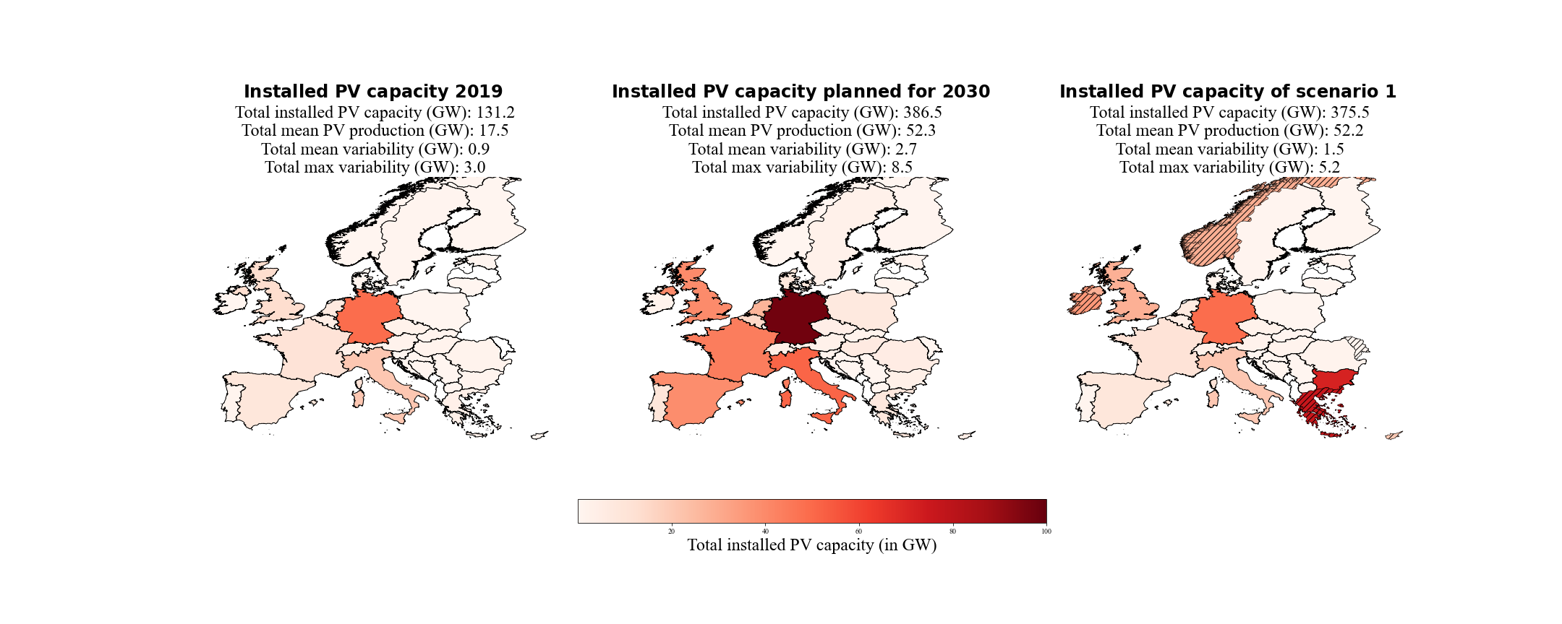

Figure : Current (2019), planned for the year 2030 (NECPs) and resulting from scenario 1 (S1) installed PV capacity distributions. S1 minimized the variability of PV power production with the constraint that the PV power production must be equal to the PV power production estimated for the year 2030 (NECPs). Hatched countries indicate that the upper bound (potential for roof-top mounted PV systems) is reached.

The IC distribution derived under the conditions of S1 is shown in the third plot of Figure 6. The total mean PV power production is almost the same as the one estimated with NECPs for 2030 (0.1 GW difference), which was the constraint for this scenario. The mean variability could be reduced from 2.7 GW to 1.5 GW and the maximum variability could be reduced from 8.5 GW to 5.2 GW. This refers to a percentual reduction from 5.2% to 2.9% for the mean variability and from 16.3% to 10.0% for the maximum variability. The reduction of the variabilities, with keeping the PV power production constant, could be achieved with an overall less total installed PV capacity of 375.5 GW (compared to 386.5 GW planned for 2030). An overview of the results can also be found in Table 4 page 45.

Figure 7 shows in which countries the additional (difference between 2030 and 2019) installed PV capacities are distributed to with the plans from NECPs (left) and with our approach to reducing the PV power production variability (right). In contrast to what is planned by NECPS, the method chosen to reduce the PV power production variability favours countries in South-eastern and North-western Europe. Hatching indicates countries where the installed PV capacity has reached the upper bound of the linear least-squares problem, which is defined as the potential for roof-top mounted PV systems (Tröndle et al., 2019).

Figure : Additional installed PV capacities planned for the year 2030 (NECPs) and of scenario 1 (S1). S1 minimized the variability of PV power production with the constraint that the PV power production must be equal to the PV power production estimated for the year 2030 (NECPs). Hatched countries indicate that the upper bound (potential for roof-top mounted PV systems) is reached.

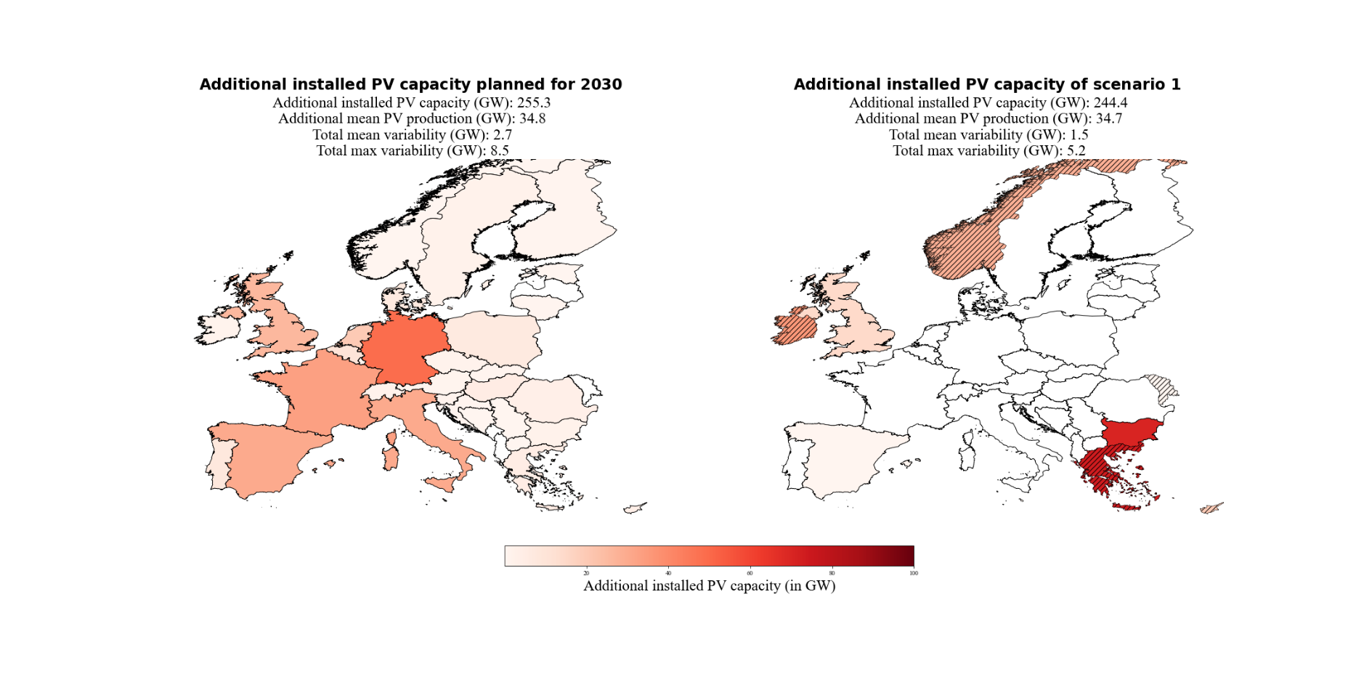

Since the method favours country on the South-eastern and North-western edge of Europe it is interesting to see, which countries are the next favourites if no more PV systems can be placed in an already considered country. Therefore, we analyzed what happens when setting the upper bound of already considered countries to their current (2019) installed PV capacity. With this approach, no PV systems will be placed in this country and one can see which country is the next favourite and by how much it increases the variability. This is done one after the other, first for the South-eastern countries Greece, Bulgaria, Romania, Serbia and Italy and afterwards for the North-western countries the United Kingdom, Norway, Ireland and Finnland. The results can be found in Figure 8. Hatched white countries are the ones that no additional placement of PV systems where allowed. It can be seen that as soon as the upper bound of a South-eastern country is hit the optimization starts to place the installed capacity to an adjacent country until the point is reached where variability is better reduced by adding the installed PV capacity to countries more West (Italy and Spain). The same is true for countries in North-west where at some point the method starts to place the installed PV capacity more East (Finnland and Denmark). It indicates that suppressing a South-eastern/North-Western distribution makes a South-western/North-eastern distribution the best solution to reduce the variability.

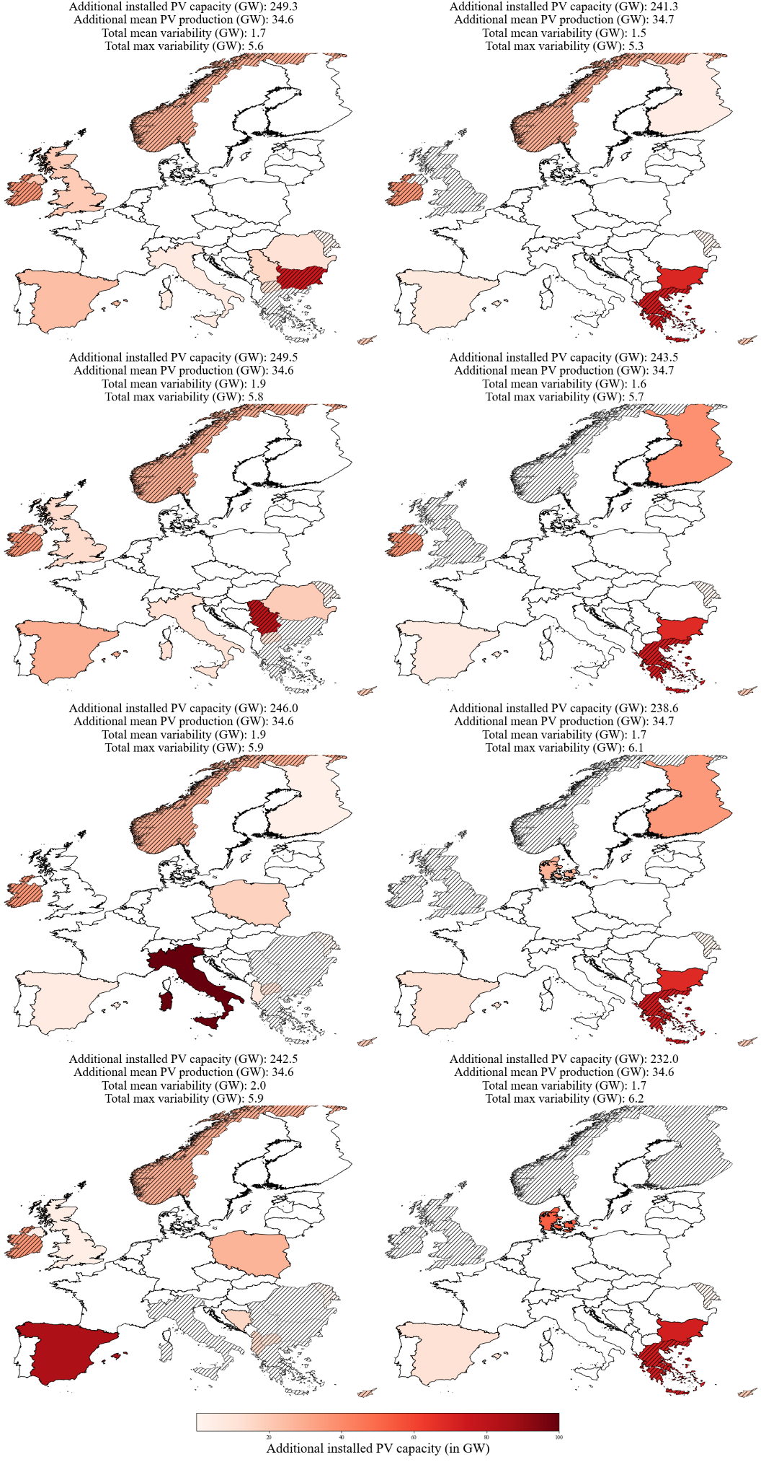

Figure : Additional installed PV capacities of modified scenario 1 (S1).The upper bound of some countries (hatched, white) are set to their current installed PV capacity. No additional PV systems will be placed in this country. This is done one after the other, first for the South-eastern countries (upper-left to lower-left panel): Greece, Bulgaria, Romania-Serbia, and Italy. Afterwards for the North-western countries (upper-right to lower-right panel): the United Kingdom, Norway, Ireland and Finnland. Hatched colored countries indicate that the upper bound (potential for roof-top mounted PV systems) is reached.

A detailed impression of the over-and underproduction for every weather regime and season compared to their seasonal mean is shown in Figure 9. The IC distribution for scenario S1 reduces the deviation of PV power production from the seasonal mean in 25 of 32 cases (pairs of four season / eight WRs). It also shows that changes from under- to overproduction in weather regimes are possible with different distributions and vice versa.

The consolidated view of the variability (Figure 10) makes clear that the variability tends to be higher in mid-season (spring and autumn). Also, the maximum variability (black markers) is higher in mid-season with the peak in autumn for all three distributions. Figure 10 also shows that the distribution of S1 reduces the mean and maximum variability in every season and total.

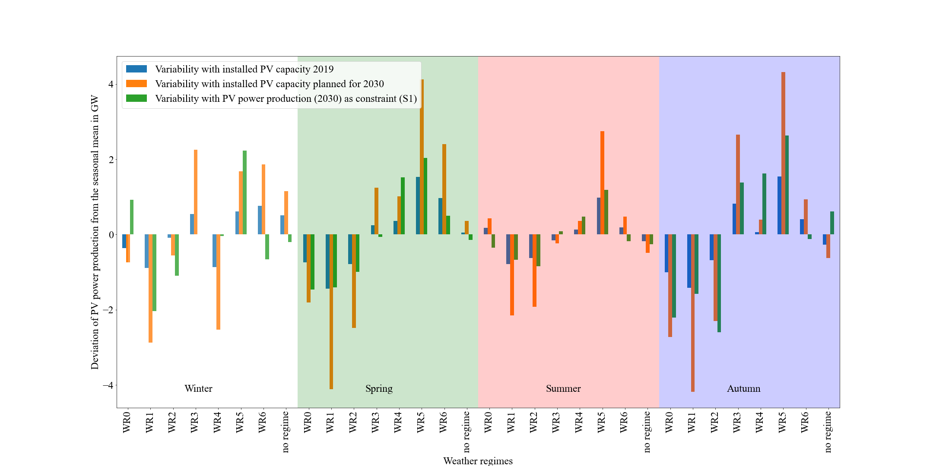

Figure : Deviation of the PV power production from the seasonal mean per weather regime and season. In blue the variability for the current situation (2019), in orange the estimated variability with the planned installed capacities for the year 2030 (NECPs) and in green the estimated variability with the installed capacity distribution for scenario 1.

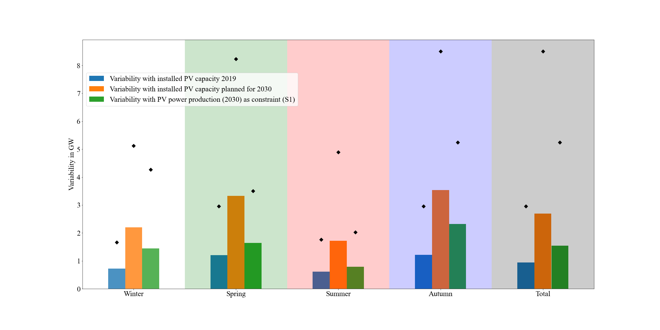

Figure : Mean (bars) and maximum (black markers) consolidated (over all weather regimes) variability per season and overall (total). In blue the variability for the current situation (2019), in orange the estimated variability with the planned installed capacities for the year 2030 (NECPs) and in green the estimated variability with the installed capacity distribution for scenario 1.

### Scenario 2 (S2) – PV IC in 2050

The results of scenario S2 are shown in Figure 11. The top right panel refers to the scenario calculated with the lowest estimate of 0.891 TW for the year 2050 by IRENA (S2-1), the bottom left panel refers to the scenario calculated with the middle estimate of 1.94 TW for the year 2050 by Energy Watch Group(S2-2) and the bottom right panel refers to the scenario calculated with the highest estimated of 8.8TW for the year 2050 by SolarPower Europe (S2-3). Since the latest estimate of 8.8TW is already higher than the sum of the potential installed capacity for roof-top mounted PV systems (which is used as upper bound), we defined the upper bound for this scenario as five times larger. This can be done because free-field PV systems are not considered in our method for the upper bound. The reason to do so is that the free-field PV systems always compete with wind turbines. To avoid this trade-off, we only use roof-top mounted PV systems except for this scenario S2-3. The installed capacities per country are presented as a percentage of the total installed capacity, to make a comparison between the three results easier. The top left panel shows the upscaled installed PV capacity distribution to the year 2050. The upscaling is done so that the percentage of the total IC per country remains the same as in the year 2019. Since all three plots of the upscaled installed PV capacity distribution for the three used estimates for the year 2050 would look identical, we only show the plot with the estimate of 1.94 TW. But the total installed capacity and the variability with the three estimates are different and can be found in Table 5, page 46.

The mean change in PV power production from one weather regime to another of the interpolation is 5.4% (remains for all interpolation the same because the percentual distribution remains as well). Our method was able to reduce it to 3.3%, 3.6% and 3.5% which refers to a reduction in mean variability of 2.5 GW, 4.7 GW and 22.1 GW, respectively. The maximum changes in PV power production from one weather regime to another of the interpolation is 16.9% (remains for all interpolations the same because the percentual distribution remains as well). This could be reduced to 10.7% (S2-1), 11.9% (S2-2) and 11.6% (S2-3) which refers to a reduction in maximum variability of 7.4 GW, 13.1 GW and 63.0 GW, respectively. An overview of the results can also be found in Table 5 page 46.

In the distributions of S2, South-eastern and North-western countries are still favoured (as in S1). But Spain and Italy also get a share of the capacities. Since the total installed capacities are much higher than in scenario S1, the upper bounds of the countries are more often reached (hatched countries). The method reacts by placing additional capacity in neighbouring countries. This can also be seen by a comparison of S2-1 (Figure 11, first row) and S2-2 (Figure 11, second row). With higher total installed capacities, the upper bounds are more often reached and neighbouring countries receive the remaining capacities and the distribution gets flatter. It goes along with the observation presented in Figure 8, page 36.

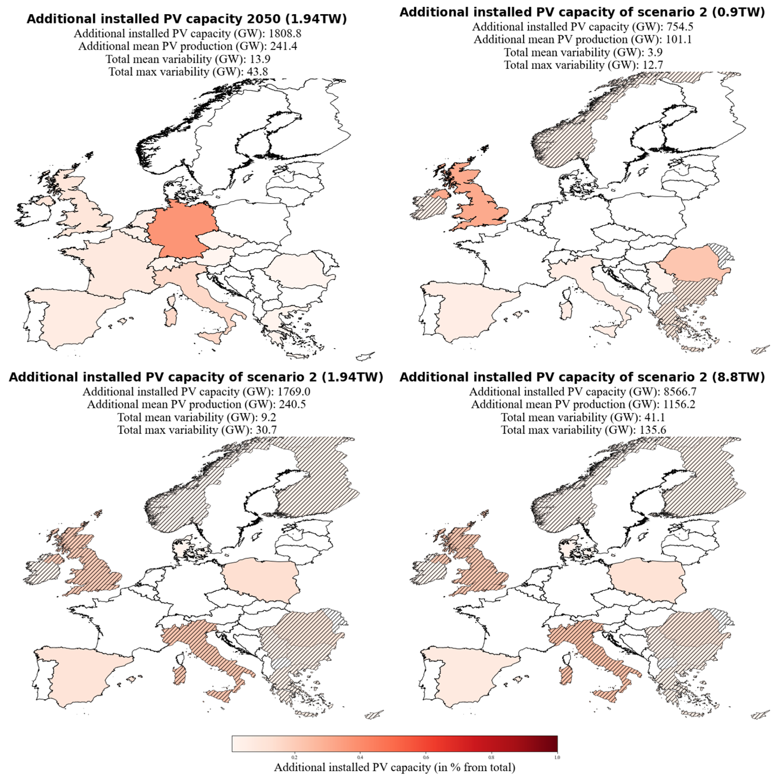

Figure : Additional installed PV capacities of 2050 (upscaled from the distribution of 2019) and of scenario 2-1, 2-2 and 2-3. Scenario 2-1, 2-2 and 2-3 minimize the variability of PV power production with the constraint that the power production must be equal to the PV power production estimated with the upscaeld for the year 2050. Basis for the interpolation are the estimates by IRENA, Energy Watch Group and SolarPower Europe. Their estimated needed total installed PV capacity are 0.891 TW, 1.94TW and 8.8 TW for the year 2050. Hatched countries indicate that the upper bound (potential for roof-top mounted PV systems) is reached.

### Scenario 3 (S3) – Cost minimization

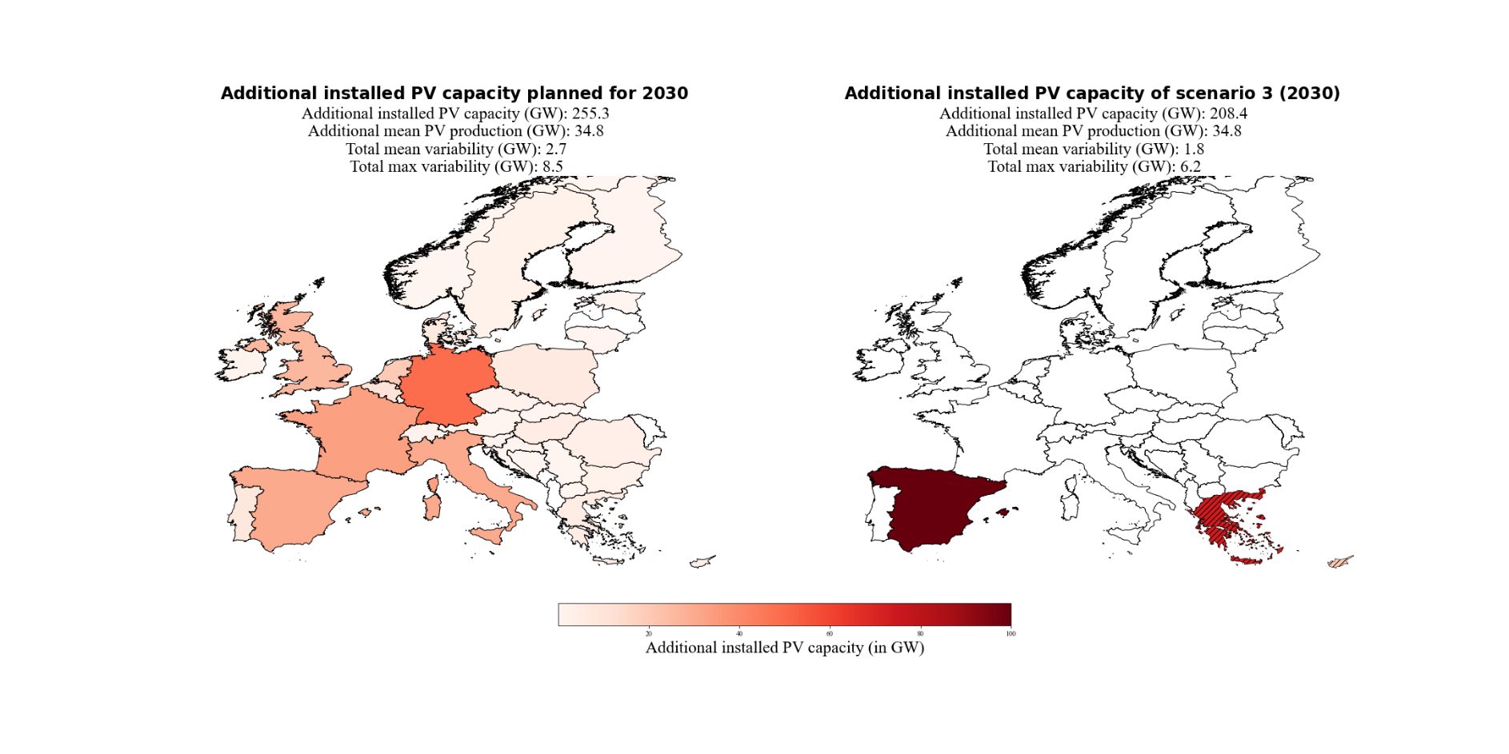

Figure : Additional installed PV capacities planned for the year 2030 (NECPs) and of scenario 3 (S3). S3 minimized the variability of PV power production and the installed PV capacities with the constraint that the power production must be equal to the power production estimated for the year 2030 (NECPs). Hatched countries indicate that the upper bound (potential for roof-top mounted PV systems) is reached.

With the focus on cost and variability minimization, we see a shift from the South-Eastern / North-western distribution (S1) to a South-eastern / South-western distribution (Figure 12, second plot). The mean variability could still be reduced from 2.7 GW to 1.8 GW (1.5 GW in S1). This means that the reduction potential for the mean variability gets reduced from 44.4% (S1) to 33.3% (S3). The maximum variability could be reduced from 8.5 GW to 6.2 GW (5.2 GW in S1). Which decreases the reduction potential from 38.8% (S1) to 27.1%. The benefit of S3 is that it takes 35.9 GW less installed PV capacity to produce the same amount of electricity compared to S1.

By doing the same analysis with the estimate of 1.94TW for the year 2050 (Europe Watch Group, S2-2), we get the distribution shown in Figure 13. The method now places all the installed capacities to Southern countries because the capacity factors are generally higher for Southern Europe than Northern Europe (Table 2) and the variability can still be reduced with a distribution from South-West to South-East. The mean variability gets reduced from 13.9 GW to 11.9 GW (9.2 GW in S2-2) and the maximum variability gets reduced from 43.8 GW to 35.0 GW (30.7 GW in S2-2). Which is a decrease of the mean variability reduction potential from 33.8% (S2-2) to 14.4% and a decrease of the maximum variability reduction potential from 29.9% to 20.1%. S3-2 needs 166.8 GW less installed capacity to produce on average 4.4 GW more electricity than S2-2.

### Scenario 4 (S4) –Coverage of country-specific electricity consumption with PV systems

Figure : Additional installed PV capacities of 2050 (left panel; interpolated from the distribution of 2019 with the estimate of 1.94 TW installed PV capacity by the Energy Watch Group) and of scenario 3 (S3; right panel). S3 minimized the varability of PV power production and the installed PV capacities with the contraint that the power production must be equal to the power production estiamted for the year 2050. Hatched countries indicate that the upper bound (potential for roof-top mounted PV systems) is reached.

The scenarios examined so far, scenario S1 to S3, ended up with putting more IC to geographically somewhat extreme regions of Europe, like Greece or Scandinavia. In practice, such a distribution of power production would necessitate substantial capacities for power transfer from the production regions to the consumers in other parts of Europe. This motivates investigating yet another scenario where countries want to be self-sufficient to a certain extent. S4-1 enforces a flatter distribution because of the constraint that 10% of the country-specific consumption must be produced with PV systems in the year 2030. The 10% are chosen because already 13.5% of the total electrical consumption equals the total estimated PV power production for the year 2030 with the NECPs. This implies that higher coverages than 13.5% can only be achieved with installed PV capacities that produce more power than the estimates for the year 2030 with the NECPs. And a comparison of the variability with different PV power productions would not be feasible.

The results are shown in Figure 14. All countries get their needed installed capacities to cover 10% of their consumption and the rest is again distributed to South-eastern and North-western Europe. The flatter distribution is at the expense of the variability reduction potential. It reduces from 44.4% (S1) to 29.6% for the mean variability and reduces from 38.8% to 29.4% for the maximum variability. This means that we are reducing the total mean variability from 2.7 GW to 1.9 GW (1.5 GW in S1) and the total maximum variability from 8.5 GW to 6.0 GW (5.2GW in S1).

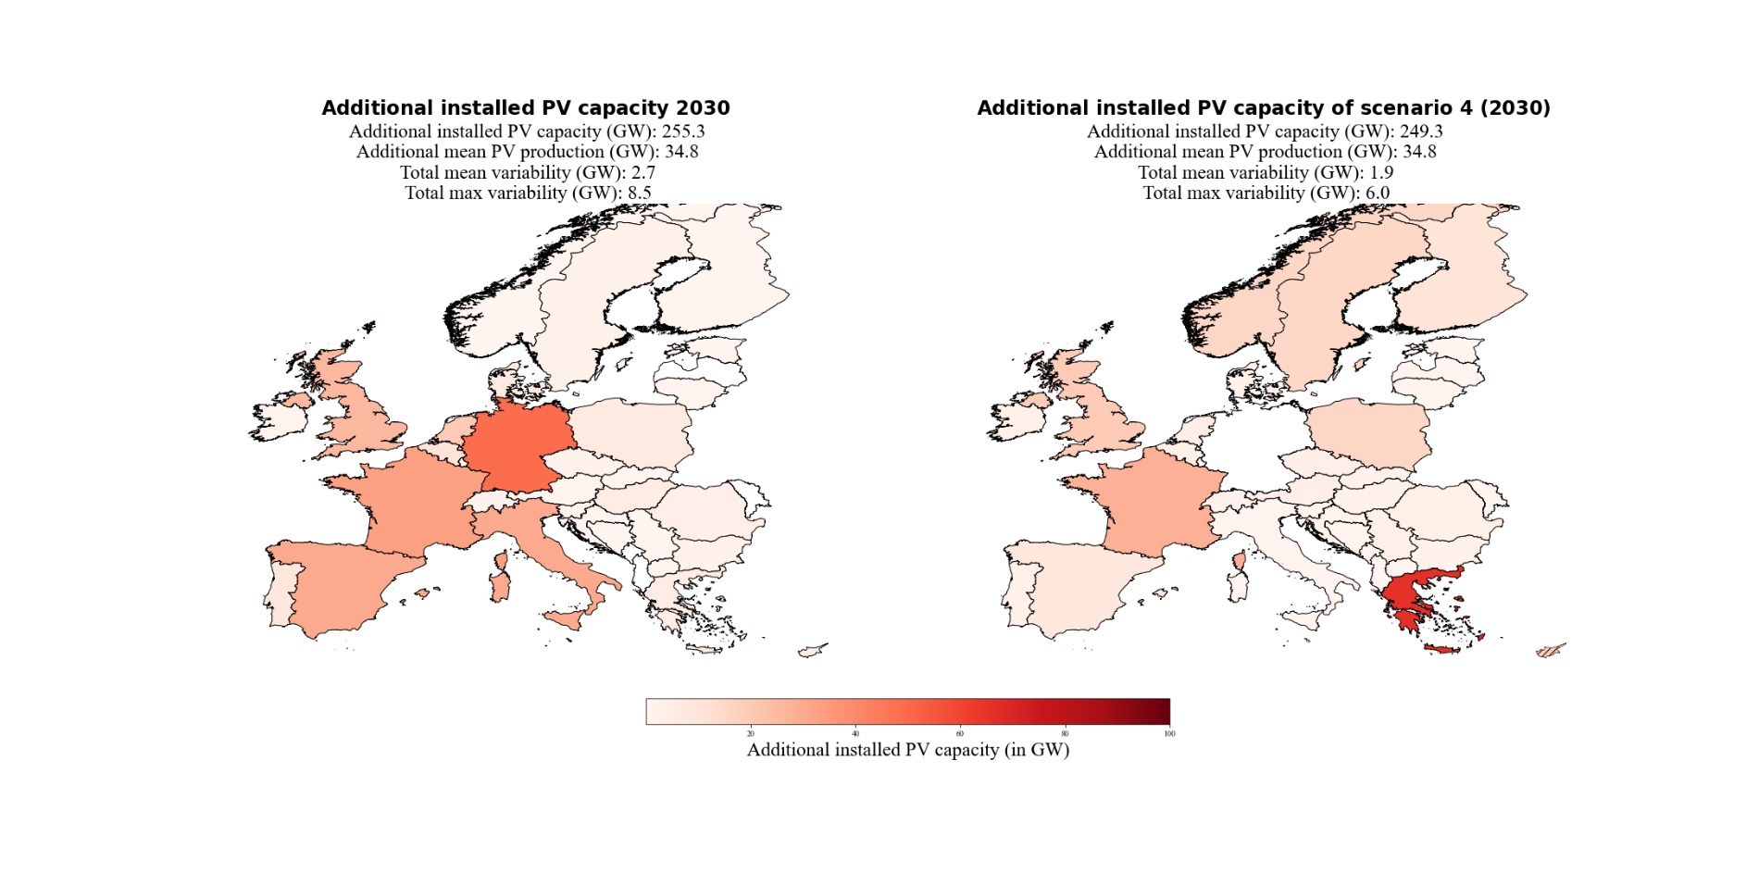

Figure Additional installed PV capacities planned for the year 2030 (NECPs) and of scenario 4-1 (S4-1). S4-1 minimized the varability of PV power production with the contraint that the PV power production must be equal to the PV power production estiamted for the year 2030 (NECPs) and 10% of the inland electricity consumptions must be coverd with PV power production by the countries themselfe.

The same analysis but with the estimate of 1.94 TW installed capacity for the year 2050 by the Energy Watch Group and the constraint that 30% of the consumption per country must be covered with PV power production, yields to the results presented in Figure 15. The flatter distribution is again at the expense of the mean variability reduction potential. It decreases from 33.8% (S2-2) to 28.1%. Which is a reduction from 13.9 GW to 10.0 GW (9.2 GW in S2-2). Interestingly the maximum variability reduction potential increases within this scenario from 29.9% (S2-2) to 30.4%. Which is a reduction from 43.8 GW to 30.5 GW (30.7 GW in S2-2).

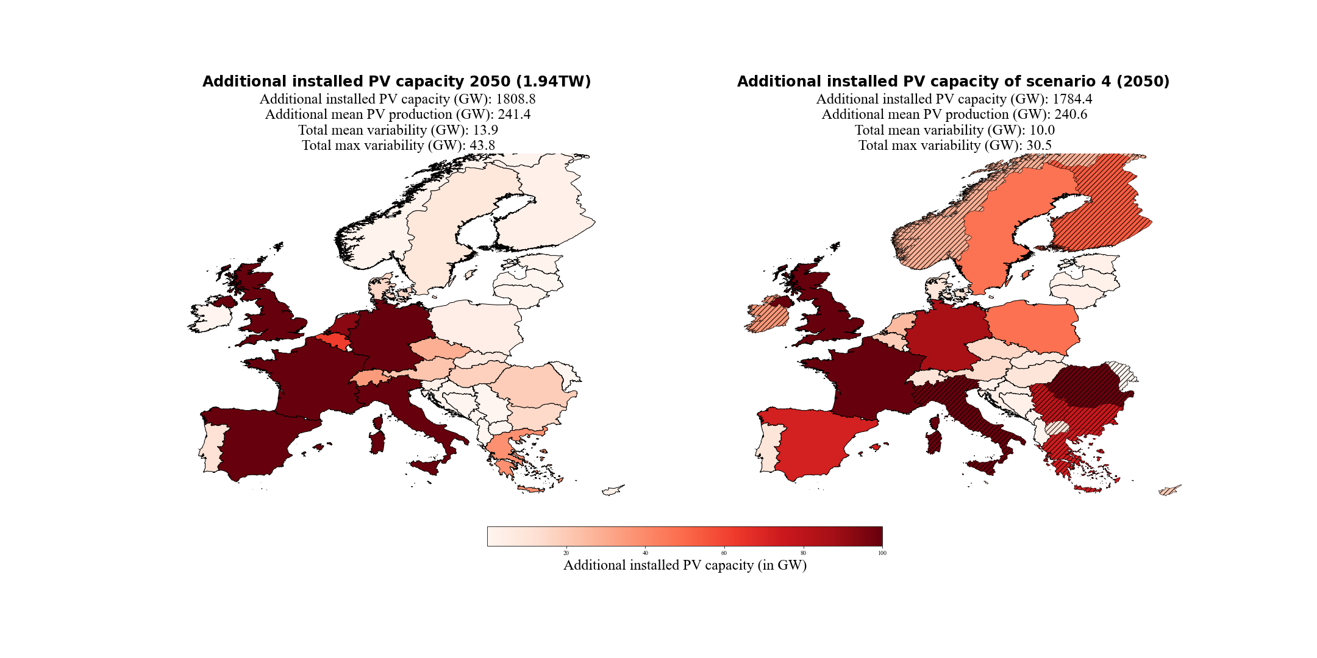An overview of all the important results of the four scenarios can be found in Table 4 and Table 5. They have separated into all results for the year 2030 (Table 4) and all results for the year 2050 (Table 5), to make a comparison between the different scenarios for the same year easier. A detailed analysis of the over-and underproductions for every weather regime and season compared to their seasonal mean and the consolidated view of the variabilities for every scenario can be found in the appendix Figure 16 - Figure 28.

Figure : Additional installed PV capacities of 2050 (interpolated from the distribution of 2019 with the estimate of 1.94 TW installed PV capacity by the Energy Watch Group) and of scenario 4-1 (S4-1). S4-1 minimized the varability of PV power production with the contraint that the PV power production must be equal to the PV power production estiamted for the year 2050 and 30% of the inland electricity consumptions must be coverd with PV power production by the countries themselfe. Hatched countries indicate that the upper bound (potential for roof-top mounted PV systems) is reached.

Table : Overview of all the important variables of the three scenarios of the year 2030 and their reference data. Scenario S1 is only constrained by equal PV power production. Scenario S3-1 is constrained by equal PV power production and cost minimization. Scenario S4-1 is constrained by equal PV power production and that 10% of the country-specific consumption must be produced with PV systems.

|  |  |  |  |  |  |
| --- | --- | --- | --- | --- | --- |
|  | 2019 | 2030  NECPs | S1  2030 | S3-1 2030 | S4-1 2030 |
| Installed PV capacity  [GW] | 131.2 | 386.5 | 375.5 | 339.6 | 380.4 |
| Mean PV production  [GW] | 17.5 | 52.3 | 52.2 | 52.3 | 52.3 |
| Mean variability  [GW] | 0.9 | 2.7 | 1.5 | 1.8 | 1.9 |
| Maximum variability  [GW | 3.0 | 8.5 | 5.2 | 6.2 | 6.0 |
| Mean variability / Mean PV production  [%] | 5.1% | 5.2% | 2.9% | 3.4% | 3.6% |
| Maximum variability / Mean PV production  [%] | 17.1% | 16.3% | 10.0% | 11.9% | 11.5% |
| Mean variability reduction  [GW] | - | - | 1.2 | 0.9 | 0.8 |
| Maximum variability reduction  [GW] | - | - | 3.3 | 2.3 | 2.5 |
| Mean variability reduction  [%] | - | - | 44.4% | 33.3% | 29.6% |
| Maximum variability reduction  [%] | - | - | 38.8% | 27.1% | 29.4% |

Table : Overview of all the important variables of the three scenarios for the year 2050 and their reference data. Scenario 2-1 to 2-3 are constrained by equal PV power production. Scenario S3-2 is constrained by equal PV power production and const minimization. Scenario 4-2 is constrained by equal PV power production and that 30% of the country-specific consumption must be produced with PV systems.

|  |  |  |  |  |  |  |  |  |
| --- | --- | --- | --- | --- | --- | --- | --- | --- |
|  | 2050 0.891 TW | 2050 1.94 TW | 2050  8.8 TW | S2-1 (2050) 0.891 TW | S2-2 (2050) 1.94 TW | S2-3 (2050) 8.8 TW | S3-2 (2050) 1.94 TW | S4-2 (2050) 1.94TW |
| Installed PV capacity  [GW] | 891.0 | 1940.0 | 8800.0 | 885.6 | 1900.2 | 8697.8 | 1733.4 | 1915.6 |
| Mean PV production  [GW] | 118.9 | 258.9 | 1174.4 | 118.6 | 258.0 | 1173.7 | 262.4 | 258.1 |
| Mean variability  [GW] | 6.4 | 13.9 | 63.2 | 3.9 | 9.2 | 41.1 | 11.9 | 10.0 |
| Maximum variability  [GW | 20.1 | 43.8 | 198.6 | 12.7 | 30.7 | 135.6 | 35.0 | 30.5 |
| Mean variability /  Mean PV production  [%] | 5.4% | 5.4% | 5.4% | 3.3% | 3.6% | 3.5% | 4.5% | 3.9% |
| Maximum variability /  Mean PV production  [%] | 16.9% | 16.9% | 16.9% | 10.7% | 11.9% | 11.6% | 13.3% | 11.8% |
| Mean variability reduction  [GW] | - | - | - | 2.5 | 4.7 | 22.1 | 2.0 | 3.9 |
| Maximum variability reduction  [GW] | - | - | - | 7.4 | 13.1 | 63.0 | 8.8 | 13.3 |
| Mean variability reduction  [%] | - | - | - | 39.1% | 33.8% | 35.0% | 14.4% | 28.1% |
| Maximum variability reduction  [%] | - | - | - | 36.8% | 29.9% | 31.7% | 20.1% | 30.4% |

# Discussion

Our results suggest that with the derived seven weather regime for Europe it is possible to assess PV power production variability year-round. With that as a basis, we estimate how the PV power production variability could change towards the year 2030 and 2050 with the current plans for additional installed PV capacities in Europe. Furthermore, the results show that we successfully introduce a novel method to numerically find a distribution of installed PV capacities, which reduces the PV power production variability. The derived results of the four scenarios also emphasize how easily the method can be extended to implement additional constraints. In the following chapter, we put the obtained results into the context of existing literature, highlight main findings and possible implications and hint at limitations of the chosen method. We start with the weather regime classification, as they form the basis for any further analysis, then proceed to WR associated PV production and its variability under present-day conditions, before finally returning to the initial motivation of this study: in a future where energy production will be dominated by renewables, to what degree can WR associated variability of PV power production be counteracted by a clever spatial distribution of future PV systems.

## Weather regimes classification

As the weather regimes are the basis for your analysis, we first need to see how they compare with literature, if we want to compare PV power variability with literature. Although the weather regime classification is year around, our defined seven weather regimes include the four weather regimes which are found by many studies that focused only on wintertime weather regime classification (Cassou, 2008; Michelangeli et al., 1995; van der Wiel et al., 2019; Vautard, 1990). Namely the positive phase of the NAO (WR0), the negative phase of the NAO (WR2), the Atlantic ridge (WR3) and the Scandinavian blocking (WR6). Their frequencies (Figure 5 and Appendix Table 7) suggest that we are in line with these studies because they occur most often in winter, except the Scandinavian blocking. The most likely explanation for this is, that the European blocking belongs to the top four weather regime during wintertime in our analysis instead of the Scandinavian blocking. Since these two weather regimes are similar, one might be at the expense of the other because we are splitting them into two separate weather regimes.

A comparison with the seven weather regimes defined year around by Grams et al. (2017) shows that they mostly agree with our weather regime classification. Their results also include the four already discussed weather regimes with a slightly different naming convention. WR0 (NAO+) matches with Grams et al. (2017) zonal regime and WR2 (NAO-) matches with their Greenland blocking. The Scandinavian blocking (WR6) and the Atlantic ridge (WR3) have the same naming convention. Contrary to our frequencies during wintertime, Grams et al. (2017) frequencies do not determine them as the most frequent ones in winter. Overall, the frequency of occurrence per weather regime is similar but often a bit less in Grams et al. (2017) study, which, by contrast, have a larger share of no regime. Also: seasonality changes are less robust. In addition to those four weather regimes, they determined the three weather regimes Atlantic trough, European blocking, and Scandinavian trough. The European blocking is in line with our findings. Whereas the Scandinavian trough in his study is mostly comparable with the European trough in our study. But as the names state the cyclone in his study is located over Scandinavian and, in our study, over North-western Europe. Additionally, the meridional dipole is more pronounced in our results. The Atlantic trough is in good agreement with Grams et al. (2017) results. But the positive geopotential height anomaly in Southern Europe in our study is more pronounced. The differences are most likely be explained because Grams et al. (2017) results only show the results of the weather regimes during wintertime and because some details within the chosen method to classify the weather regimes differ. The difference in the definition of the reference climatology (30- vs. 90-day running mean) and the differences in the assignment of days to no regime should be emphasized here. Overall, the weather regimes classification is following findings reported by others (Cassou, 2008; Grams et al., 2017; Michelangeli et al., 1995; van der Wiel et al., 2019; Vautard, 1990).

## Capacity factor anomalies and surface weather variables

Having shown that the weather regime classification agrees with literature, we turn to the comparison of weather regime dependent quantities across studies. The surface weather variables anomalies (solar radiation and 2m temperature) and as a direct consequence the CFs anomalies are in good agreement with other studies. Especially the four well-studied weather regimes in wintertime are in line with previous results. (Bloomfield et al., 2020; Grams et al., 2017; Jones et al., 2020; Pozo-Vazquez et al., 2011; van der Wiel et al., 2019). We present a more detailed discussion about the seven weather regimes in the next seven paragraphs.

The results of the **positive phase of the NAO (WR0)** suggests a negative correlation to the surface solar radiation anomalies in Northern Europe and a positive correlation in Southern Europe (Figure 3). Consequently, CF anomalies behave similarly: during the positive phase of the NAO, Southern Europe experiences a relative surplus in PV power production, whereas PV power production is below average in Northern Europe. The correlation between NAO+ and surface solar radiation is in agreement with the study by Pozo-Vazquez et al. (2011) although it is disputed by Colantuono et al., (2014). The observed North-South gradient of the PV CF anomalies can also be observed in the study by Grams et al. (2017). And the changes throughout the seasons are consistent with them as well. The study by Van Der Wiel et al. (2019), which only focus on wintertime, stated that the surface solar radiation is close to normal during the NAO+. But a slightly North-South gradient can also be observed in their results. Our results partly agree with those, as the discrepancy between North and South decreases in winter compared to the rest of the year.

The observed negative correlation between the **negative phase of the NAO (WR2)**, the surface solar radiation and consequently the CFs anomalies in Northern Europe (negative correlation for Southern Europe) tends to be more robust. This also applies to the observed overall negative temperature anomaly in Europe. (Grams et al., 2017; Hurrell et al., 2003; Jerez et al., 2013; Pozo-Vazquez et al., 2011; van der Wiel et al., 2019). Van der Wiel et al. (2019) identified that the combination of low temperature and lower than average wind speed during the NAO- is at the risk that the demand for electricity increases the supply of electricity in Europe. Since the CF are enhanced during NAO- in Northern Europe, it might be a possibility to reduce that risk with additional installed PV capacities in this region.

The enhanced surface solar radiation and capacity factor anomalies in South-western Europe during the **Atlantic ridge (WR3)** matches well with Grams et al. (2017) and van der Wiel et al. (2019). Nevertheless, the temperature anomalies in winter found by van der Wiel et al. (2019) are less pronounced compared to our temperature anomalies defined year around. But the changes throughout the season of the CF anomalies are rather high which gives reason to assume that the surface weather variables also are higher than average. Our identified changes throughout the seasons are mostly in line with Grams et al. (2017).

The anticyclone over Scandinavian during the **Scandinavian blocking (WR6)** brings higher than normal surface solar radiation to Northern Europe. The enhanced surface solar radiation caused by descending air and therefore clear sky condition is in line with the study Amajama (2016). The resulting higher than normal 2m temperature and CFs anomalies, which is relatively constant for all seasons, are also observed by Grams et al. (2017) and van der Wiel et al. (2019).

These observations also hold for the **European blocking (WR5)**. Generally, we see enhanced surface solar radiation anomalies and therefore enhanced CF anomalies in Central Europe where the Anticyclone is located (in line with Amajama, (2016)). The seasonal change is more pronounced which partly agrees with Grams et al. (2017). The change from slightly positive CFs anomalies in Southern Europe in winter to slightly negative values in summer fits the observation by Grams et al. (2017). In contrast, they do not agree with Northern countries. As presented earlier, we found that the CF anomalies are slightly negative in winter, whereas on the other hand Grams et al. (2017) found strongly positive values. The reason for the difference is not yet clear. One could argue that the seasonal cycle has a strong influence during this weather regime in our study. Positive CF anomalies in winter are most pronounced in Southern Europe. But a northward shift towards summer can be observed and again a southward shift in autumn, which is likely to be explained by the seasonal cycle of surface solar radiation. This obvious and strong influence of the seasonal cycle cannot be observed in the other weather regime and their CF anomalies.

The surface solar radiation and CF anomalies of the **European through (WR1)** do agree to a large extent with the Scandinavian through defined by Grams et al. (2017). Also, the changes throughout the season match well. Main differences arise from Southern countries which tend to be more negative within our study in wintertime. This could be explained by the position of the cyclone which in our results are located more to the South. A comparison with a study by Jones et al. (2020), who investigated the impact of 29 Grosswetterlagen on the European Energy Sector, show that the PV power production anomalies of the Grosswetterlage TRW (trough Western Europe) and TM (through Central Europe), which are mostly comparable with the European through from our analyses, are more in line with our results.

The **Atlantic trough (WR4)** is the weather regime that agrees the least with the weather regimes defined by Grams et al. (2017). This is mainly because of the positive geopotential height anomaly in Southern Europe which in our results are more pronounced. Therefore, it could be expected that the CFs anomalies and weather variables also do not fit well. Indeed the surface solar radiation and the CF anomalies in South-eastern Europe are higher than normal within our study contrary to those reported by Grams et al. (2017). This is more in line with the study by Jones et al. (2020) who also suggest positive solar power production anomalies in South-eastern Europe during the Grosswetterlagen SWZ (cyclonic South-westerly) and SWA (anticyclonic South-westerly), which are relatable to the Atlantic trough. The negative surface solar radiation anomalies observed by Grams et al. (2017) for Northern countries fit again with our observed surface solar radiation anomalies. And the negative CF anomalies in Northern Europe in winter are in good agreement as well. But our results suggest that the already more positive CF anomalies in South-eastern Europe extend northwards during spring and autumn. This partly agrees with Grams et al. (2017) where the CF anomalies increase towards summer as well.

## Current and projected PV power production variability

Since the power production of PV is still relatively small compared to the power production of wind turbines in Europe, there are not many studies that focus on its variability. Therefore, we mainly compare our results with the study by Grams et al. (2017) who analysed its current variability but did not further investigate its reduction potential for the same reason. An overview of the comparison between our and Grams et al. (2017) results can be found in Table 6. Presented in such a way that the difference in the total installed PV capacity is considered (131.2GW in 2019 vs. 87.91GW in 2015).

Table : Comparison of PV power production and variability with the study by Grams et al. (2017).

|  |  |  |  |  |
| --- | --- | --- | --- | --- |
|  | Winter | Spring | Summer | Autumn |
| PV power production / installed PV capacity  2019 | 6.6% | 16.5% | 19.6% | 10.7% |
| PV power production / installed PV capacity  Grams et al. (2017) | 6.8% | 16.7% | 19.7% | 10.9% |
| Maximum variability / PV power production 2019 | 19.3% | 13.6% | 6.8% | 21.1% |
| Maximum variability / PV power production Grams et al. (2017) | 31.8% | 17.7% | 5.1% | 23.8% |

The PV power production divided by the PV installed capacity is nearly identical. This could be expected since the data source for the CF are the same and the percentual distribution of installed capacities from 2015 to 2019 in Europe did not change dramatically. Although the change in the percentual distribution has not changed much it might explain the small differences in the results.

The estimated variability does not fit as well as the production. But the pattern from spring, to summer, to autumn, are alike and generally of similar sizes. The result for winter shows a greater difference. The reason is not yet clear. But since PV power production is lowest in winter anyhow, and therefore also the absolute variability, it might play a less important role for general variability optimization considerations.

A closer look at the weather regimes with the highest overproduction over all of Europe shows that the highest overproduction is always during WR5 (European blocking) except for winter where it is during WR6 (Scandinavian blocking). This is in line with Grams et al. (2017) who also report the highest overproduction mainly during blocking situations. The lowest underproduction occurs always during WR1 (European through) which is more diverse in Grams et al. (2017). An overview of the over-and underproduction per weather regime and season can be found in Figure 9 and Appendix Table 8. It is worth mentioning that if a weather regime exhibits over-or underproduction it does so throughout the whole season. This gives rise to group the weather regimes accordingly. Weather regimes with a positive geopotential height anomaly (anticyclone, blocking) over the Atlantic or Continental Europe (WR3, WR4, WR5 and WR6) usually exhibits overproduction (expect WR4 winter and WR3 summer). The positive and negative phase of the NAO (WR0 and WR2) or weather regimes with negative geopotential height anomalies over Europe (cyclone) usually exhibit underproduction (expect WR0 summer). These general over- or underproduction patterns show that there are weather regimes where a reduction of PV power production variability is not possible. The method aims to align the PV power production per weather regime and season to the mean PV power production per season. But for weather regimes like e.g., WR1, which has negative CF throughout the whole season almost everywhere, this is not feasible. In other words, a gradient of the CF anomalies throughout Europe is needed that the method can achieve its aim of reducing the PV power production variability. If there is no gradient of the CF anomalies throughout Europe, the variability must be balanced from other sources. For instance, wind power production exhibits an anticorrelation to PV power production and could be used for this purpose (Grams et al., 2017). It also leads to the general question of how to balance the variable power production of renewable technologies. Because even with a clever spatial distribution of wind turbines and PV systems, a certain amount of variability will always remain which needs to be balanced. That highlights the importance of the further expansion of storage possibilities (battery, hydrogen, pumped-storage hydroelectricity, synthetic fuel, to name a few) which are needed to run a stable power grid in a fossil-free electricity-producing future.

While at the moment PV power production is still of minor importance in comparison to total power production, this is about to change in a “greener future”. Once PV power production contributes a substantial amount to total power production, the relative variabilities in Table 4 and Table 5 become substantial as well. Grams et al. (2017) stated that it needs a tenfold PV installed capacity to compete with the wind turbine power production variability. According to the plans by NECPs installed PV capacity already triples in 2030. Our results suggest that this could lead to the variability of 8.5 GW (about 8 to 9 present-day nuclear power plants) which corresponds to 16% of the foreseen wind power production variability of 51.7 GW in 2030 (Grams et al., 2017). The estimates for a 100% renewable energy – power sector by the Energy Watch Group, which is the source for our scenario S2-2, suggest that the PV installed capacity increases 19 times from the year 2015 until the year 2050. At the same time, a four-fold increase is projected for wind installed capacity. This shows that towards 2050 PV power production becomes more important. As shown in scenario S2-2 (Table 5) this could lead to a PV power production variability of 43.8 GW in the year 2050 which is more than half of the 89.6 GW wind power production variability that we get if we simply upscale (increase by a factor of four) the variability estimates by Grams et al. (2017).

The results suggest that with the current planning strategies for 2030 there will be a need for energy system operators to take the fluctuation of 8.5 GW electric power caused by PV into account. In 2050 this could massively increase from 20.1 GW to 198.6 GW, depending on the scenario. The electricity demand must always equal the production of electricity to ensure a stable power grid. This study neglected the electricity demand since the focus is on PV power production variability only. Others (Bloomfield et al., 2020; van der Wiel et al., 2019) analysed the stress for the energy system caused by wind and PV production and their dependency on weather. They determined that currently blocking situations on average have lower than normal power production with wind and PV and higher than normal energy demand. Our results suggest that PV power production is contrariwise higher on average during blocking situations. E.g., during the European blocking (WR5) PV power production is usually highest whereas it is lowest for wind power production (Grams et al., 2017). The stress for the energy system during blocking situations can be explained by the fact that currently, wind power production is still dominating over PV power production and therefore determines the production pattern. That highlights the potential to reduce the stress for the energy system if PV power production becomes more competitive to wind power production. The anticorrelation between wind and PV power production can be used to balance the electricity grid.

## Variability reduction potential

In line with other studies, the present work shows that PV power production in Europe undergoes substantial variability on time scales of several days, due to weather regimes. Two basic situations can further be distinguished: weather regimes associated with both, over and underproduction of PV power in different parts of Europe and weather regimes associated with an overall over or underproduction throughout Europe. In the former case, our study shows that suitable spatial deployment of PV panels can substantially reduce the weather regime associated variability of PV power production, as further discussed below in Sections 4.4.1 to 4.4.4. In the latter case, the spatial distribution of PV systems is shown to help little, weather regime associated variability must be counteracted by other means, as discussed below.

The results of the four scenarios suggest that the objective of reducing PV power production variability can be addressed by adding future installed PV capacities to South-eastern and North-western Europe. Visual analysis of the classified seven weather regimes goes along with these results. High and low geopotential height anomaly fields are eighter affecting half of Europe (e.g. WR0), often with a South-east/North-west gradient, or entire Europe with decreasing intensity on the edges (e.g. WR5). It also goes along with the anomalies of surface solar radiation and 2m temperature. Especially the distribution of surface solar radiation often shows a discrepancy between South-eastern and North-western Europe. And it still holds for the CF anomalies but here the distribution shifts a bit, and the discrepancy between North and South is more pronounced rather than East to West. This indicates that the CF pattern associated with the different weather regimes are fair although not entirely robust to season. It might be possible to further increase the robustness to the season by analysing monthly CF instead of seasonal CF.

### S1 - PV power production and installed capacities from NECP 2030

The estimates of S1 show that the potential of reducing mean and maximum variability is 44.4% and 38.8%, respectively. These are the highest percentual reduction for the mean and maximum variability which were achieved within our four scenarios (Table 4 and Table 5). It highlights to which extend it is possible to reduce the PV power production variability since the only constraint in this scenario is minimum PV power production (which has to equal to the PV power production estimated for 2030). A closer look at the variability per season and weather regime (Figure 9) shows that the seven cases (out of 32) where the deviation of PV power production from the seasonal mean could not be reduced, are most often related to WR4. For spring and summer, it was exclusively WR4 which could not be reduced. The changes throughout the season of WR4 (Figure 4) might explain why it is difficult to reduce the deviation of PV power production from the seasonal mean for this weather regime. In winter, the CF anomalies have the typical South-eastern / North-western pattern, which explains why the deviation from the seasonal mean nearly vanishes in winter with the IC distribution found in S1. But the CF anomalies in the rest of the seasons are generally more positive (especially in spring) and no longer a distinctive South-eastern / North-western pattern.

Three of the seven cases, where PV power production variability could not be reduced, occur in winter. Interestingly WR4 is not one of them and the deviation from the seasonal mean of it could be reduced to nearly zero. The reason why winter is the season in which most of these seven cases occurs might be because PV power production is generally lowest in winter. Since the linear least-square problem reduces the sum of the absolute deviation from the seasonal mean for each weather regime and season, winter with its lower PV power production is just less important than others. Unfortunately, winter is the season where electricity demand is highest and therefore PV power production variability plays an important role. This highlights another limit of the chosen method which does not take electricity demand into account.

### S2 - PV IC in 2050

From the results of scenario two, it is clear how important PV power production variability could become towards 2050. Depending on the projected installed PV capacity for 2050, the maximum variability reaches a value between 20.1 GW and 198.6 GW. The maximum variability is particularly interesting because this is the amount that needs somehow to be balanced. As mentioned earlier our method was able to reduce it to 12.7 GW - 135.6 GW. So one would need 7 to 63 nuclear power plants less if the PV plants are distributed ‘cleverly’. An important implication of these findings is that before further massive deployment of PV systems, one must consider if the cost for balancing the difference of these variabilities is higher or lower than the cost that would arise by investing in the expansion of the current power grid to ensure its transmission. This is also a limitation of the presented results as the transmission of electricity is completed neglected and one unlimited power grid for Europe is assumed. The main reason to do so is that the focus of this study lies in the potential of reducing PV power production variability. There is, so to speak, the basic information of PV power production variability for further planning strategies towards a fossil-free electricity generation future. It can be used as a factor to assess whether the expansion of the European power grid is worthwhile. Another reason to neglect the transmission is that it is still unclear if transmission or storage is economically more advantageous (Bremen, 2010).

The distribution of S2 (Figure 11) goes along with the distribution of S1. South-eastern and North-western countries are still favoured. But since the total installed PV capacities have increased, the upper bound of countries are more often hit (e.g. Romania), and other countries like Italy and Spain get higher installed capacities. This indicates that at some point, the variability reduction potential is no longer best addressed by adding the installed capacities to South-eastern Europe. The result shows that this point is reached as soon as Greece and Bulgaria are (almost) at their upper bound. Afterwards, the method starts to place the installed capacities to Spain (already in S1) and Italy (S2). It is a similar observation presented in scenario S1, Figure 8, page 36.

The achieved reduction potentials of S2 are slightly lower than the reduction potential of S1. As mentioned, with the higher defined installed PV capacity of S2, the countries' upper bound are more often hit. Therefore, the method places the installed capacities elsewhere and that comes at the expense of the variability. It can nicely be seen by comparing S2-1 and S2-2 (Figure 11 and Table 5) where the installed capacities are different, but the upper bounds remain. The mean variability reduction decreases about 5.3% and the maximum variability decreases about 6.9% (from S2-1 to S2-2).

The distribution and reduction potential of S2-3 and S2-2 are similar because we increased the upper bounds by three times in scenario S2-3. As mentioned, this has been done because the sum of the total installed capacity of the upper bound is already lower than the highest installed capacity assumption for the year2050 of 8.8 TW. One interpretation of this finding is that if the upper bounds and the installed capacity are increased similarly (the installed capacity of S2-3 is also roughly increased five times compared to S2-2), the distribution and reduction potential remains unchanged. This might lead to a general optimal distribution pattern that could linearly increase with increasing installed capacities as long as the upper bounds are not hit. Remarkable is also that the potential of the roof-top mounted PV system (Tröndle et al., 2019) is smaller than the highest estimates of needed installed PV capacity for the year 2050. This highlighting the importance of free field mounted PV systems. Since additional free field mounted PV systems are always in competition with wind turbines, the defined upper bound is based only on roof-top mounted PV systems.

### S3 - Cost minimization

The findings of scenario three highlight that reducing PV power production variability does not strongly conflict with lowering costs. Instead, it is possible to achieve the same PV power production with 18% less additional installed PV capacity while still decreasing the PV power production variability (S3-1, Figure 12 and Table 4). And the mean and maximum reduction potential of 33.3% and 27.1% is even within reach of S1 and S2. But the distribution to only three countries (Cyprus, Greece and Spain) also show its limit.

S3-2 suggests that it is getting harder to reduce the PV power production variability with a higher total installed PV capacity and cost reduction considerations. A reduction in the variability could still be achieved but decreases drastically to roughly a quarter of the mean reduction potential and half of the maximum reduction potential of S2-1. Also, the benefit in reducing the cost decreases. Where S3-1 could produce the same amount of electricity with 18% less additional installed PV capacity it decreases in S3-2 to 11%. The reason is probably again because the upper bounds are more often hit. This can also be seen in Figure 13 (right plot) where nearly all Southern countries are at their upper bound.

### S4 - Coverage of country-specific electricity consumption with PV systems 37

The enforcement of a flatter distribution in S4, by the constraint, that a certain amount of electricity consumption must be produced with PV by every country itself, indicates that a reduction of the variability is still feasible although its potential is lowered. The reduction potential estimated for 2030 and 2050 is nearly identical. The most likely explanation is that in S4-1 10% of inland electricity consumptions must be covered with PV systems, and in S4-2 30%. An interesting side note within this scenario is that 13.5% of the current total electricity consumption of Europe is equal to the estimates of PV power production estimated with installed PV capacity planned for 2030. The results of S4 may be of interest when planning larger solar systems and their location. Even in an already present flat installed PV capacity distribution, a new large solar system in a key country like Greece could reduce the PV power production variability. Additionally, the flatter distribution has the impact that the need to exchange electricity over power lines is reduced.

# Conclusion

The growth of installed PV capacity increases power production variability because of its weather dependent production pattern. Its current and future impact on the energy system is crucial for transmission system operators to balance the power grid. We have assessed present PV power production variability in Europe based on weather regime classification with 500 hPa geopotential height fields from ERA5 and country-specific PV capacity factors by renewables.ninja. Using the National energy and climate plans of European countries, we have shown where the PV power production variability is heading for 2030. Also, estimates for 2050 have been calculated based on different fossil-free electricity-producing future scenarios. This fulfils the first aim of this study to assess current and project future PV power production variabilities. We have achieved the study's second aim by introducing a method based on linear least-square optimization, showing the potential of reducing PV power production variability with a clever distribution of PV systems within Europe. With this method, we have extended the study by Grams et al. (2017) first by analyzing PV power production instead of wind. Second, it uses a more sophisticated method to find a distribution that reduces the power production variability. To our knowledge, this is the first study to examine PV power production variability potential with a distribution of PV systems within Europe based on weather regime classification and linear least-square optimization.

## Core findings

We have estimated that already in 2030, the change in PV power production from one weather regime to another could increase to up to 8.5 GW. A variability of 8.5 GW implies that other power plants or storage facilities must produce this electricity to balance the power grid. For instance, roughly eight nuclear power plants. We have shown that under the condition of an unlimited power grid (transmission), a South-eastern/North-western distribution of PV systems in Europe can reduce this variability by roughly 40% to 5.2GW (scenario S1, page 32). Furthermore, the investigations show that lowering PV power production variability is not exclusively on the cost's expense. It is feasible to reduce the variability projected to 2030 by roughly 30% with 9% less installed PV capacity (scenario S3-1, page 40). Finally, we have demonstrated that even in an enforced flatter distribution of PV systems by minimal inland production of electricity with PV, a significant reduction in variability is still possible (scenario S4, page 41).

The installed PV capacity must increase massively towards 2050 if we want to achieve a fossil-free electricity-producing Europe. And so will the PV power production variability. We have estimated the maximum variability with different scenarios in 2050 from 20.1 GW up to 198.6 GW (scenario S2, page 53). A distribution found with the linear least-square optimization could reduce the maximum variability by 7.4 up to 63 GW. Or to come back to our already used example: roughly seven up to 63 fewer nuclear power plants are needed to balance the variability caused by PV power production in 2050. We have demonstrated that also in 2050, a reduction in PV power production variability is not exclusively on the costs’ expense. But the potential of roof-top mounted PV system per country is more often reached, and our method places additional installed PV capacities to countries where the variability reduction potential is smaller. This lowers the potential to reduce the variability by roughly one third.

To summarize, the increase in installed PV capacity could enhance the variable power production into the Europen power grid massively. As so long as the PV power production is of minor importance to the total electricity production in Europe, its variability is not yet crucial. But we have shown that this could change rapidly in future. This study suggests that before further massive deployment of PV systems, it is worth considering the potential that lies in a clever distribution of PV systems within Europe. If we do not take this opportunity, the variable power input will be unnecessarily more extensive and more research and innovation are needed to balance the power grid sustainably.

## Recommendation for future work

Our findings suggest that higher PV power production occurs mainly in weather regimes with a blocking situation. Others (Grams et al., 2017; van der Wiel et al., 2019) have shown that the energy system's current stress is highest during these conditions because wind power production is lowest and demand is high. Therefore, the further growth of installed PV capacity could decrease the energy system's stress in blocking situations. This anticorrelation between wind and PV power production patterns shows the potential of a combined analysis. Since our method is easily extendable, it is worth adding the capacity factors for wind power production and find a PV systems and wind fleets distribution that reduced the power production variability. Furthermore, wind capacity factors are also easily accessible in the same form as PV capacity factors from renewables.ninja. This should make the expansion of the implemented method straight forward.

Another improvement of the presented method could be to use capacity factors on a smaller scale than country-specific ones. For example, one can imagine that in a large country like Germany, the capacity factors in the South differ significantly from the capacity factors in the North. An analysis on a smaller scale would take that into account and increase the number of locations to distribute PV systems.

# Appendix

|  |  |  |  |  |
| --- | --- | --- | --- | --- |
|  | Winter (DJF) | Spring (MAM) | Summer (JJA) | Autumn (SON) |
| WR0 | 19.4% | 13.7% | 12.6% | 12.4% |
| WR1 | 11.9% | 16.0% | 14.5% | 16.4% |
| WR2 | 13.9% | 10.1% | 6.2% | 9.1% |
| WR3 | 13.9% | 12.5% | 15.6% | 16.6% |
| WR4 | 9.7% | 14.3% | 17.6% | 11.7% |
| WR5 | 14.0% | 13.3% | 14.1% | 12.6% |
| WR6 | 11.4% | 13.1% | 11.8% | 14.1% |
| no regime | 5.8% | 7.0% | 7.5% | 7.0% |

Table : The defined seven weather regimes and no regime and their frequency throughout the season.

Table : Current (2019) and projected (2030) PV power production anomaly (difference to the seasonal mean) estimates per weather regime and season. The projection to 2030 is based on the National Energy and climate plans (NECPs). Framed in blue are the lowest anomalies per season, and framed in red are the highest anomalies per season.

|  |  |  |  |
| --- | --- | --- | --- |
|  |  | PV power production anomaly 2019 (GW) | PV power production anomaly 2030 (GW) |
| Winter Mean production: 8.6 GW | **WR0** | -0.36 | -0.74 |
| **WR1** | -0.89 | -2.87 |
| **WR2** | -0.08 | -0.55 |
| **WR3** | 0.55 | 2.26 |
| **WR4** | -0.87 | -2.52 |
| **WR5** | 0.62 | 1.68 |
| **WR6** | 0.77 | 1.87 |
| **no regime** | 0.52 | 1.15 |
| Spring Mean production: 21.7 GW | **WR0** | -0.74 | -1.80 |
| **WR1** | -1.43 | -4.11 |
| **WR2** | -0.78 | -2.49 |
| **WR3** | 0.25 | 1.24 |
| **WR4** | 0.36 | 1.02 |
| **WR5** | 1.53 | 4.12 |
| **WR6** | 0.97 | 2.40 |
| **no regime** | 0.05 | 0.36 |
| Summer Mean production: 25.7 GW | **WR0** | 0.18 | 0.42 |
| **WR1** | -0.78 | -2.15 |
| **WR2** | -0.63 | -1.92 |
| **WR3** | -0.16 | -0.24 |
| **WR4** | 0.13 | 0.36 |
| **WR5** | 0.98 | 2.74 |
| **WR6** | 0.19 | 0.47 |
| **no regime** | -0.18 | -0.49 |
| Autumn Mean production: 14.0 GW | **WR0** | -1.00 | -2.72 |
| **WR1** | -1.41 | -4.18 |
| **WR2** | -0.68 | -2.30 |
| **WR3** | 0.82 | 2.65 |
| **WR4** | 0.06 | 0.39 |
| **WR5** | 1.54 | 4.32 |
| **WR6** | 0.41 | 0.93 |
| **no regime** | -0.28 | -0.62 |

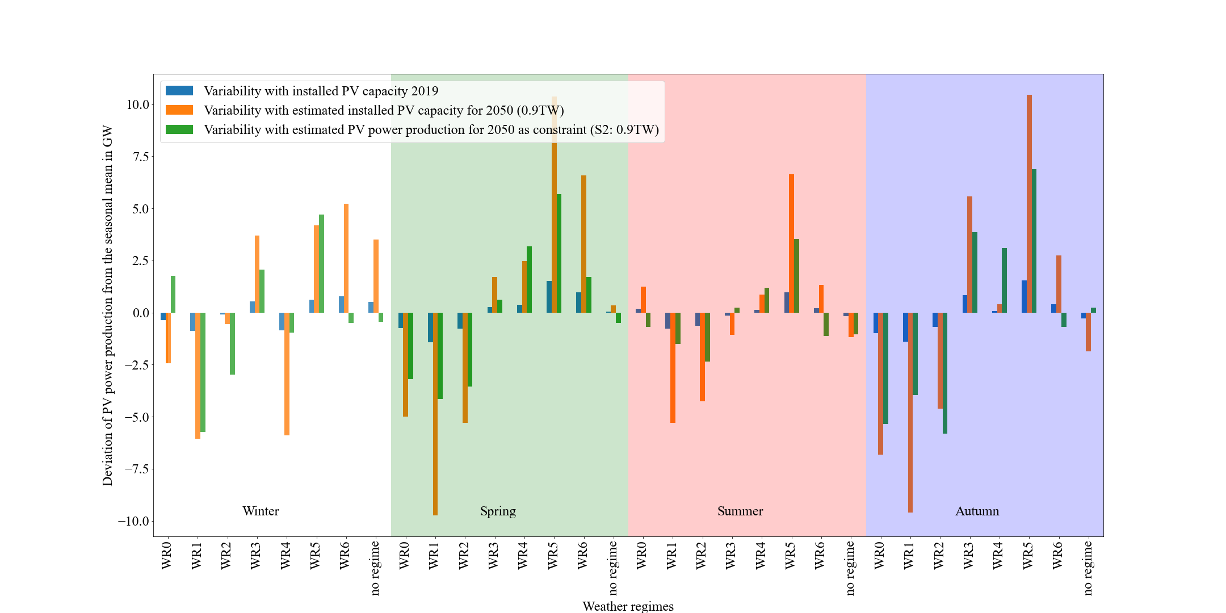

Figure : Deviation of the PV power production from the seasonal mean per weather regime and season. In blue the variability for the current situation (2019), in orange the estimated variability with the upscaled installed capacities to the year 2050 (0.9 TW) and in green the estimated variability with the installed capacity distribution for scenario 2-1.

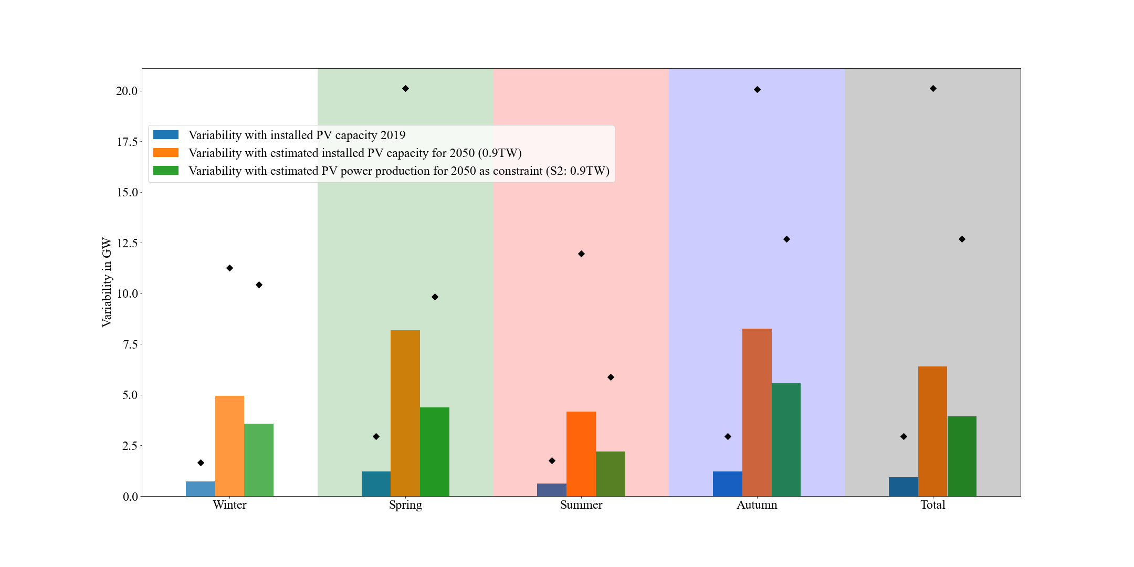

Figure : Mean (bars) and maximum (black markers) consolidated (over all weather regimes) variability per season and overall (total). In blue the variability for the current situation (2019), in orange the estimated variability with the upscaled installed capacities to the year 2050 (0.9 TW) and in green the estimated variability with the installed capacity distribution for scenario 2-1.

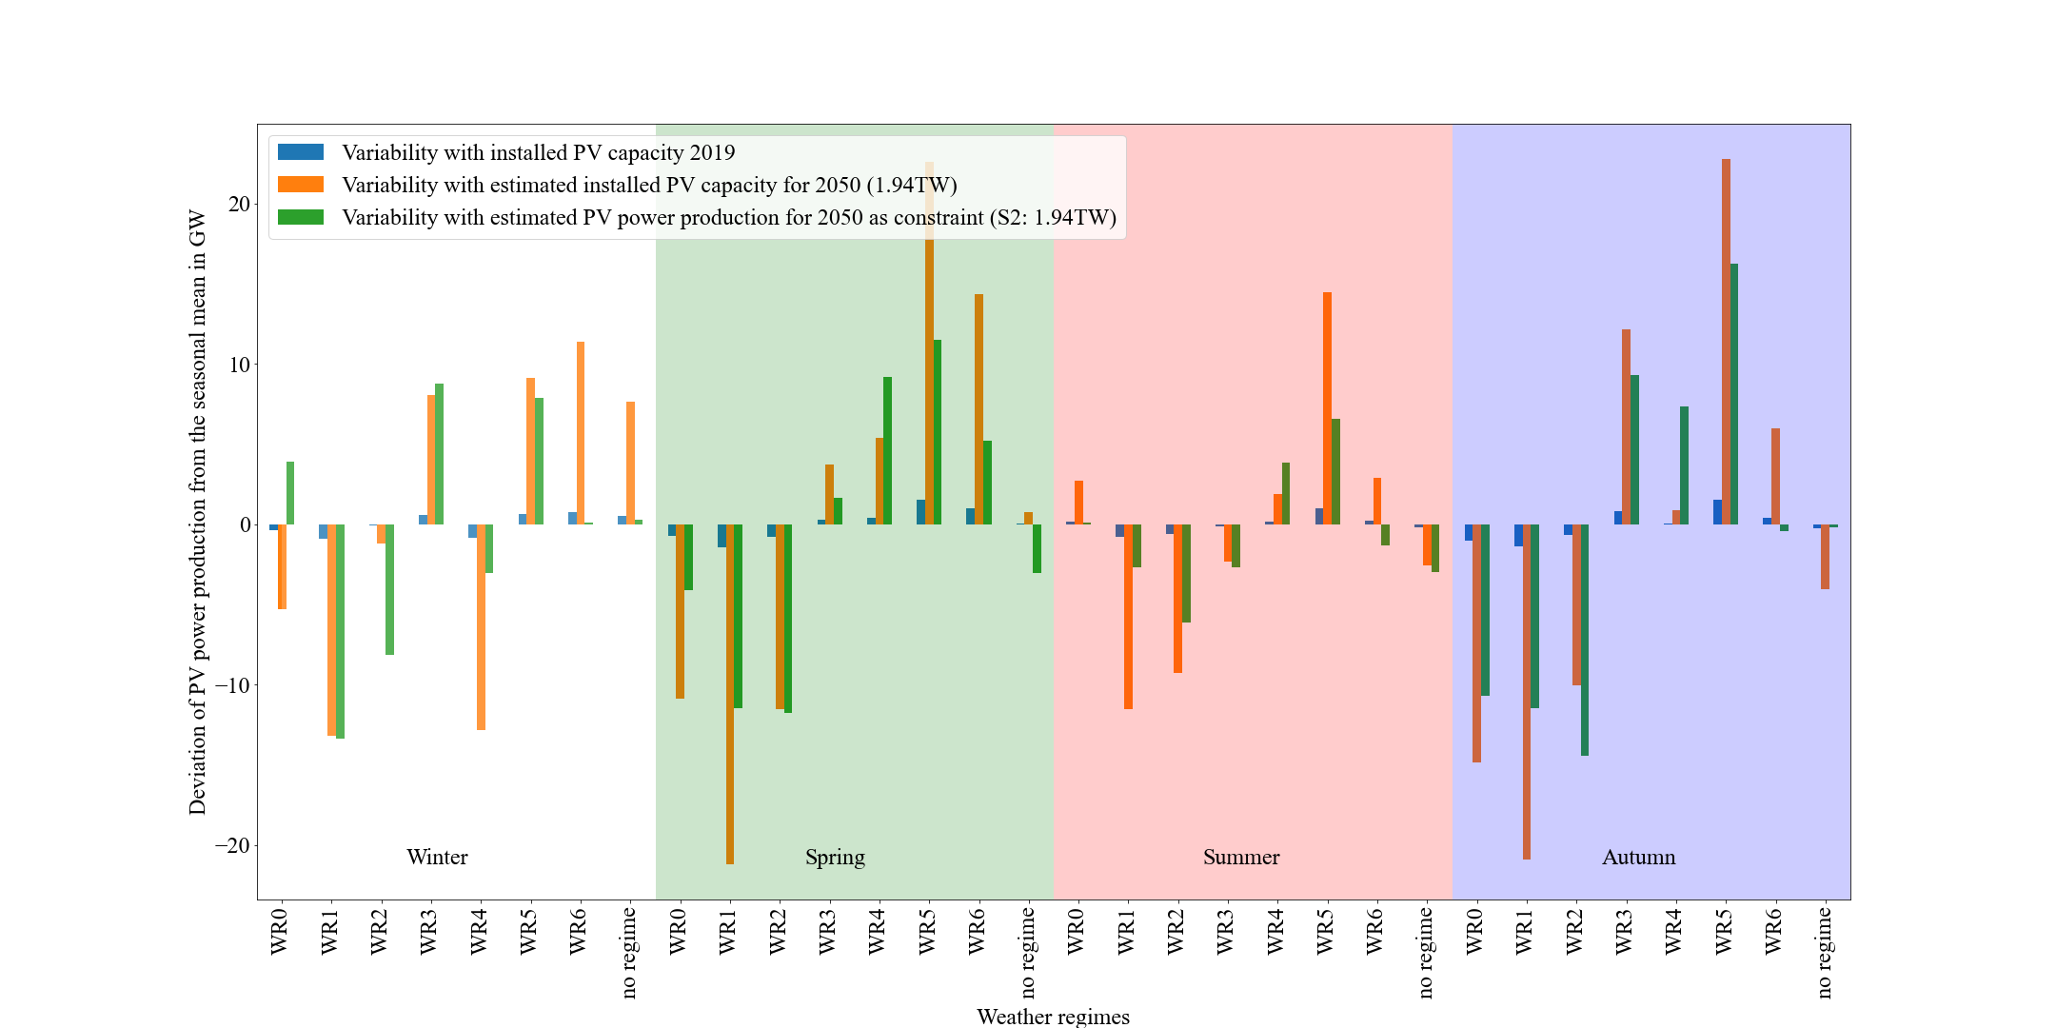

Figure : Deviation of the PV power production from the seasonal mean per weather regime and season. In blue the variability for the current situation (2019), in orange the estimated variability with the upscaled installed capacities to the year 2050 (1.94 TW) and in green the estimated variability with the installed capacity distribution for scenario 2-2.

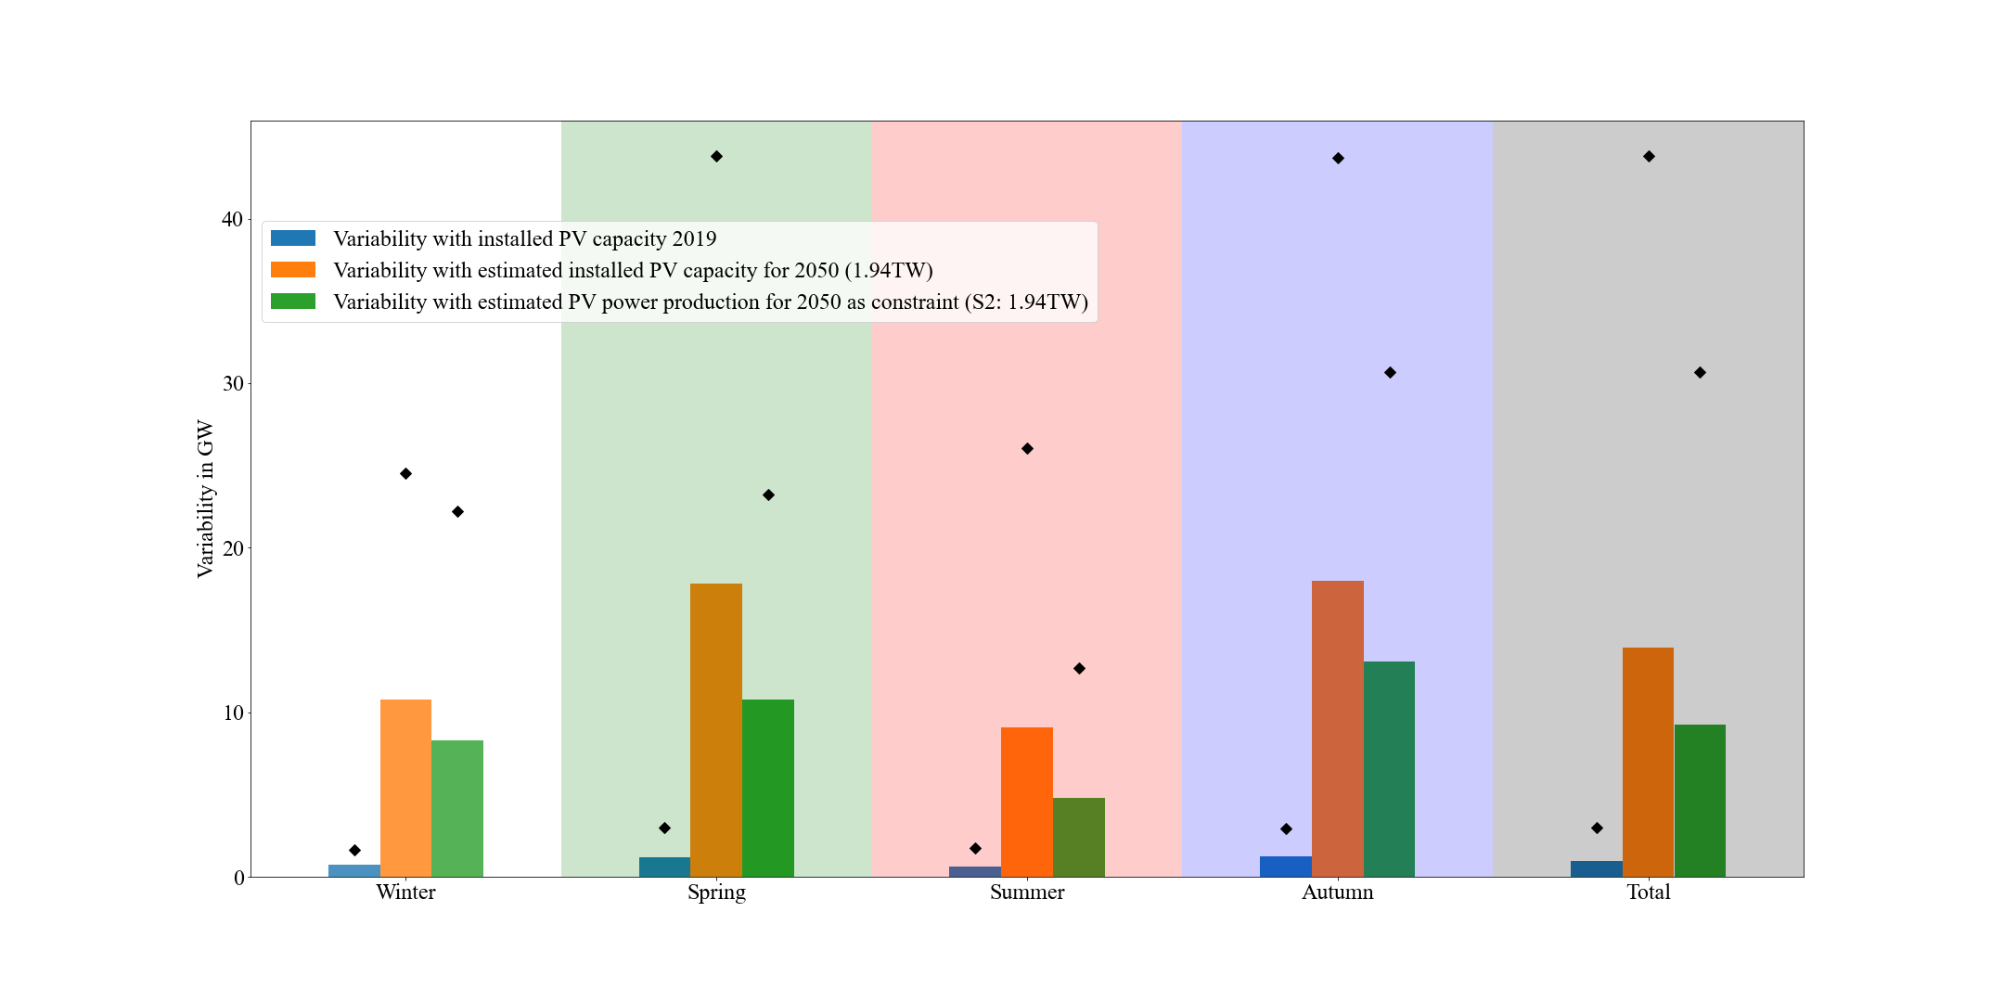

Figure : Mean (bars) and maximum (black markers) consolidated (over all weather regimes) variability per season and overall (total). In blue the variability for the current situation (2019), in orange the estimated variability with the upscaled installed capacities to the year 2050 (1.94 TW) and in green the estimated variability with the installed capacity distribution for scenario 2-2.

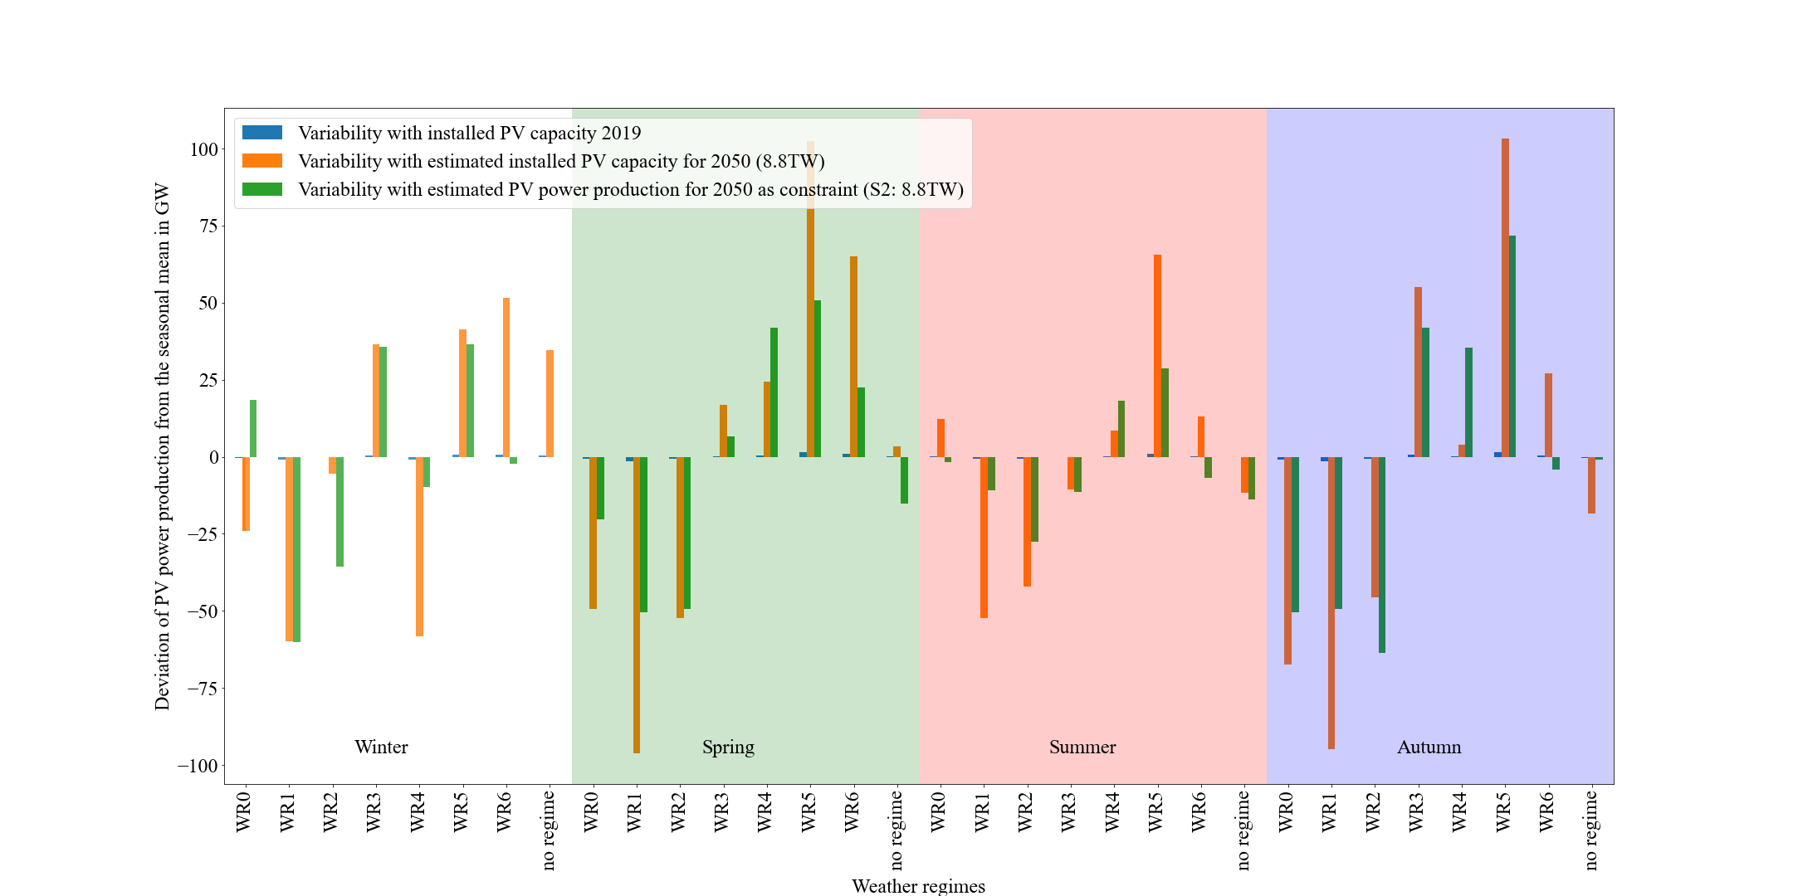

Figure : Deviation of the PV power production from the seasonal mean per weather regime and season. In blue the variability for the current situation (2019), in orange the estimated variability with the upscaled installed capacities to the year 2050 (8.8 TW) and in green the estimated variability with the installed capacity distribution for scenario 2-3.

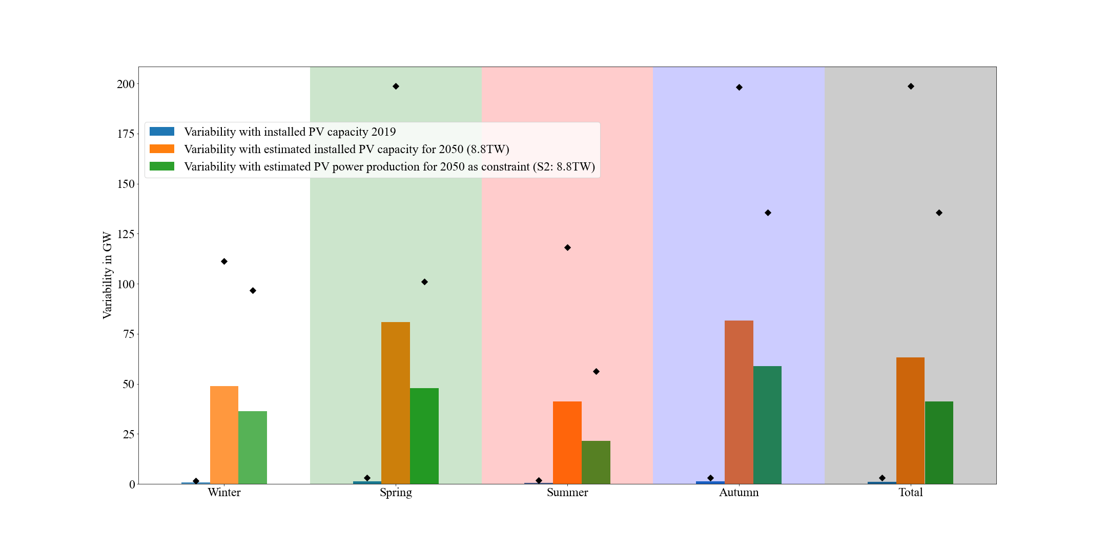

Figure : Mean (bars) and maximum (black markers) consolidated (over all weather regimes) variability per season and overall (total). In blue the variability for the current situation (2019), in orange the estimated variability with the upscaled installed capacities to the year 2050 (8.8 TW) and in green the estimated variability with the installed capacity distribution for scenario 2-3.

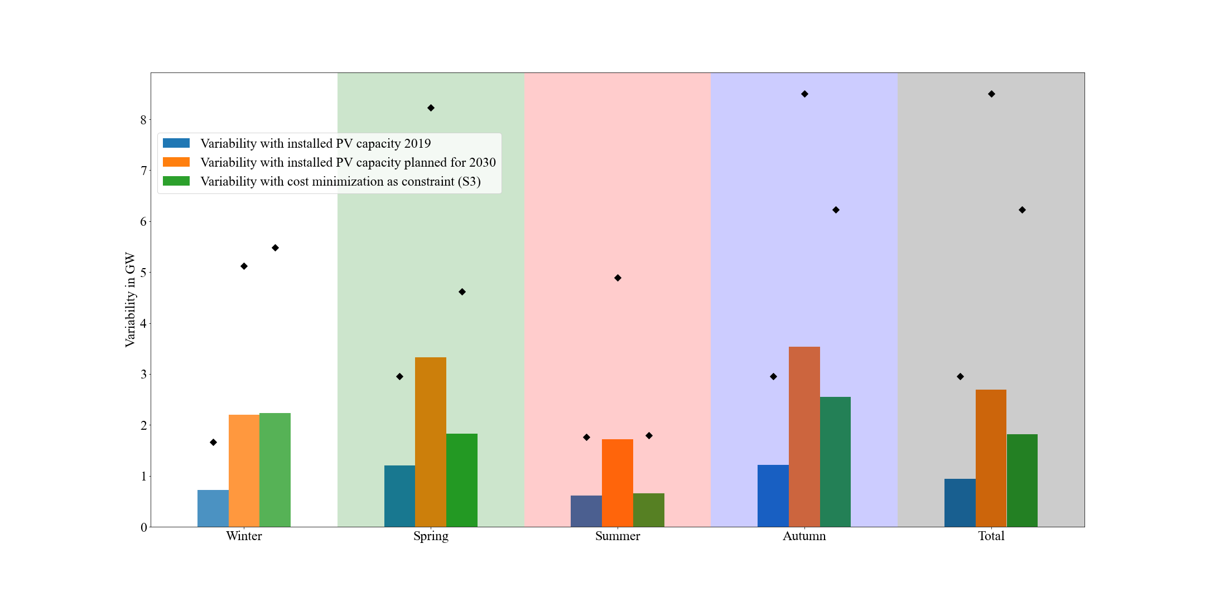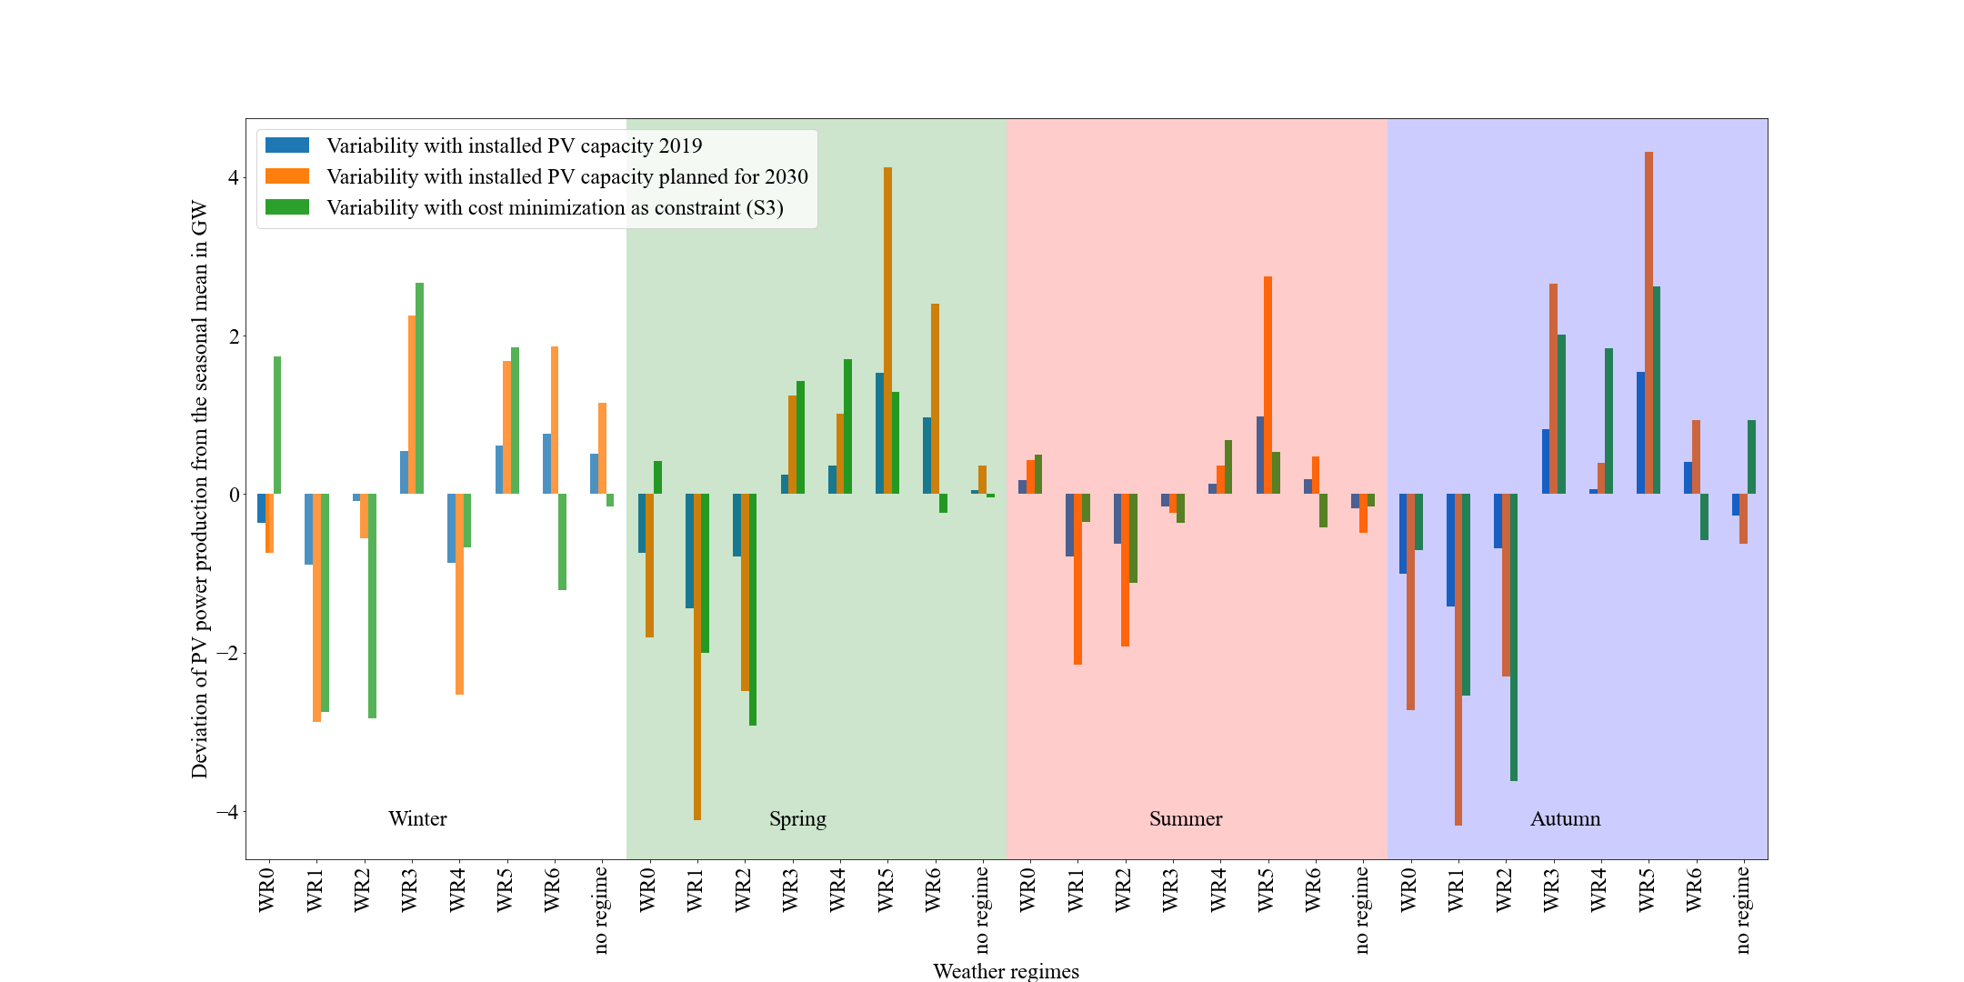

Figure : Deviation of the PV power production from the seasonal mean per weather regime and season. In blue the variability for the current situation (2019), in orange the estimated variability with the planned installed capacities for the year 2030 (NECPs) and in green the estimated variability with the installed capacity distribution for scenario 3-1.

Figure : Mean (bars) and maximum (black markers) consolidated (over all weather regimes) variability per season and overall (total). In blue the variability for the current situation (2019), in orange the estimated variability with the planned installed capacities for the year 2030 (NECPs) and in green the estimated variability with the installed capacity distribution for scenario 3-1.

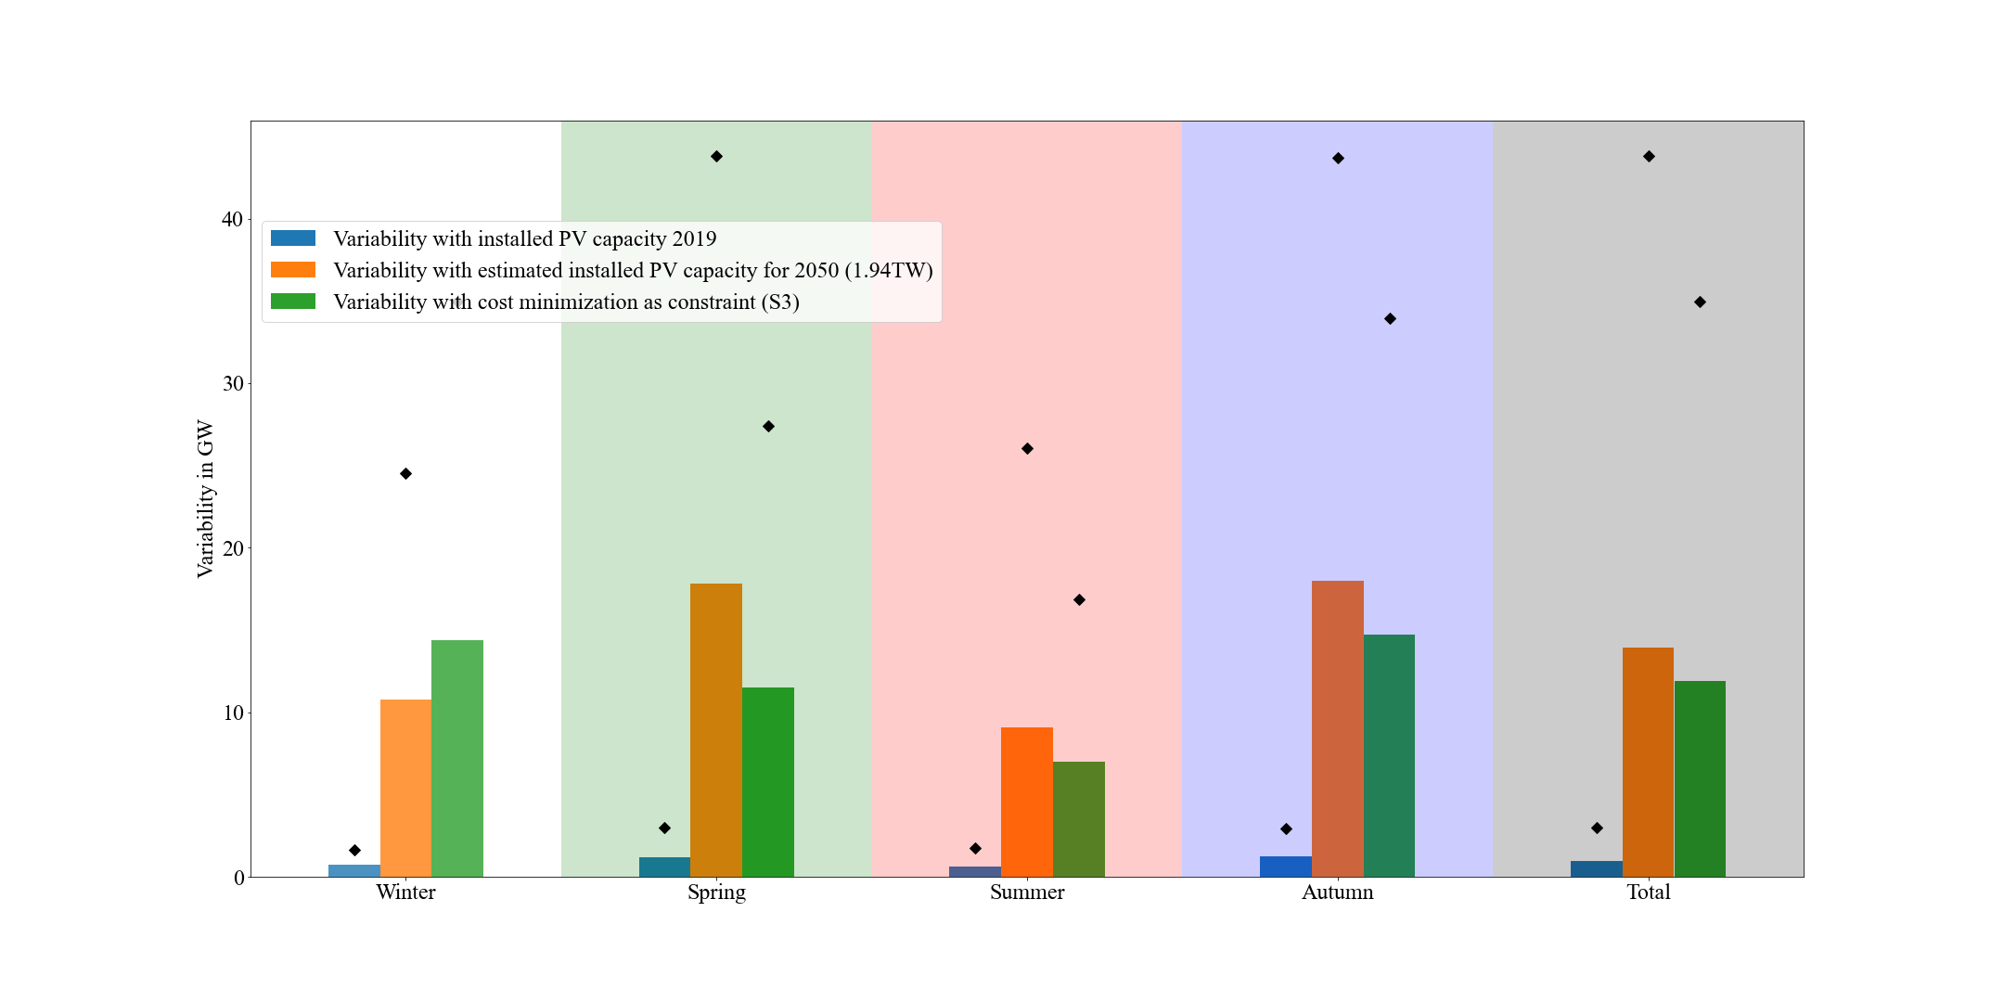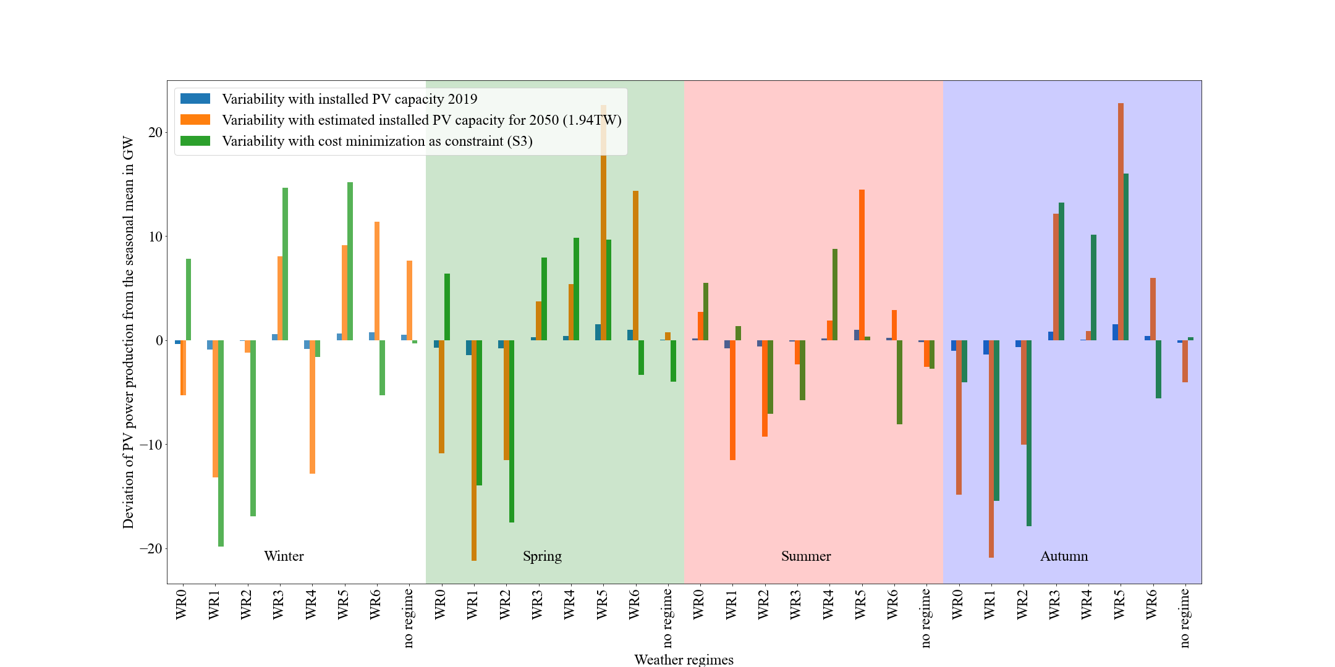

Figure : Deviation of the PV power production from the seasonal mean per weather regime and season. In blue the variability for the current situation (2019), in orange the estimated variability with the upscaled installed capacities to the year 2050 (1.94 TW) and in green the estimated variability with the installed capacity distribution for scenario 3-2.

Figure : Mean (bars) and maximum (black markers) consolidated (over all weather regimes) variability per season and overall (total). In blue the variability for the current situation (2019), in orange the estimated variability with the upscaled installed capacities to the year 2050 (1.94 TW) and in green the estimated variability with the installed capacity distribution for scenario 3-2.

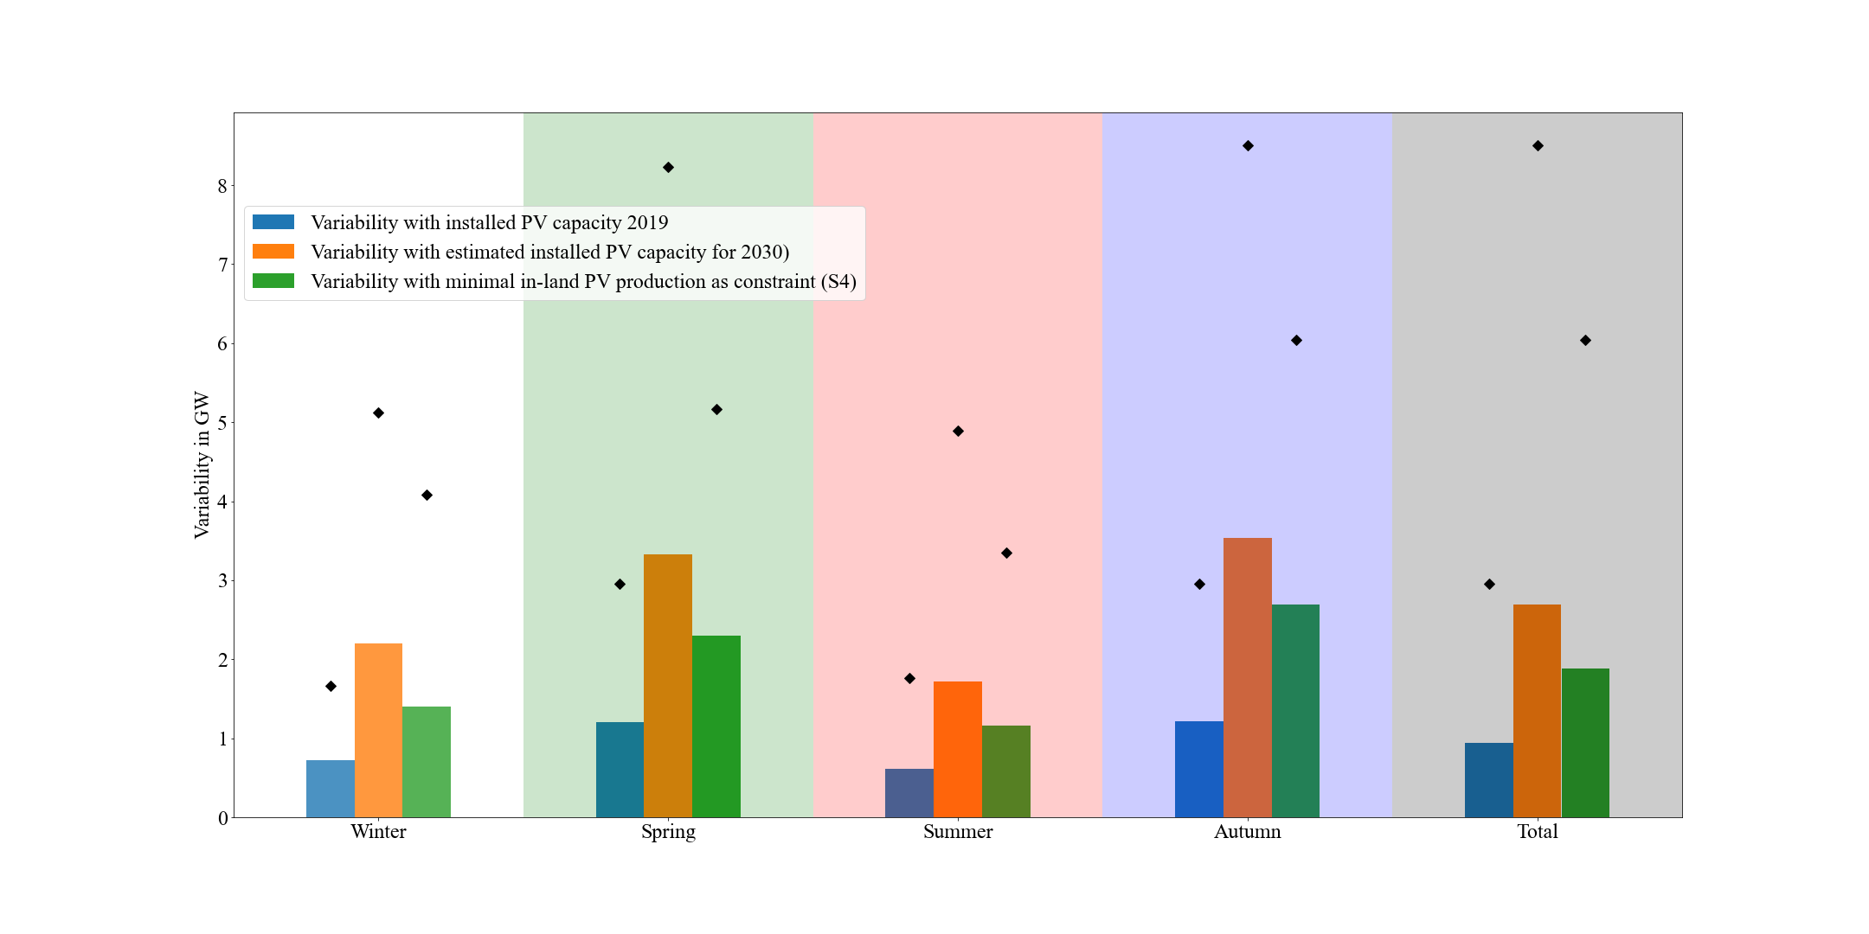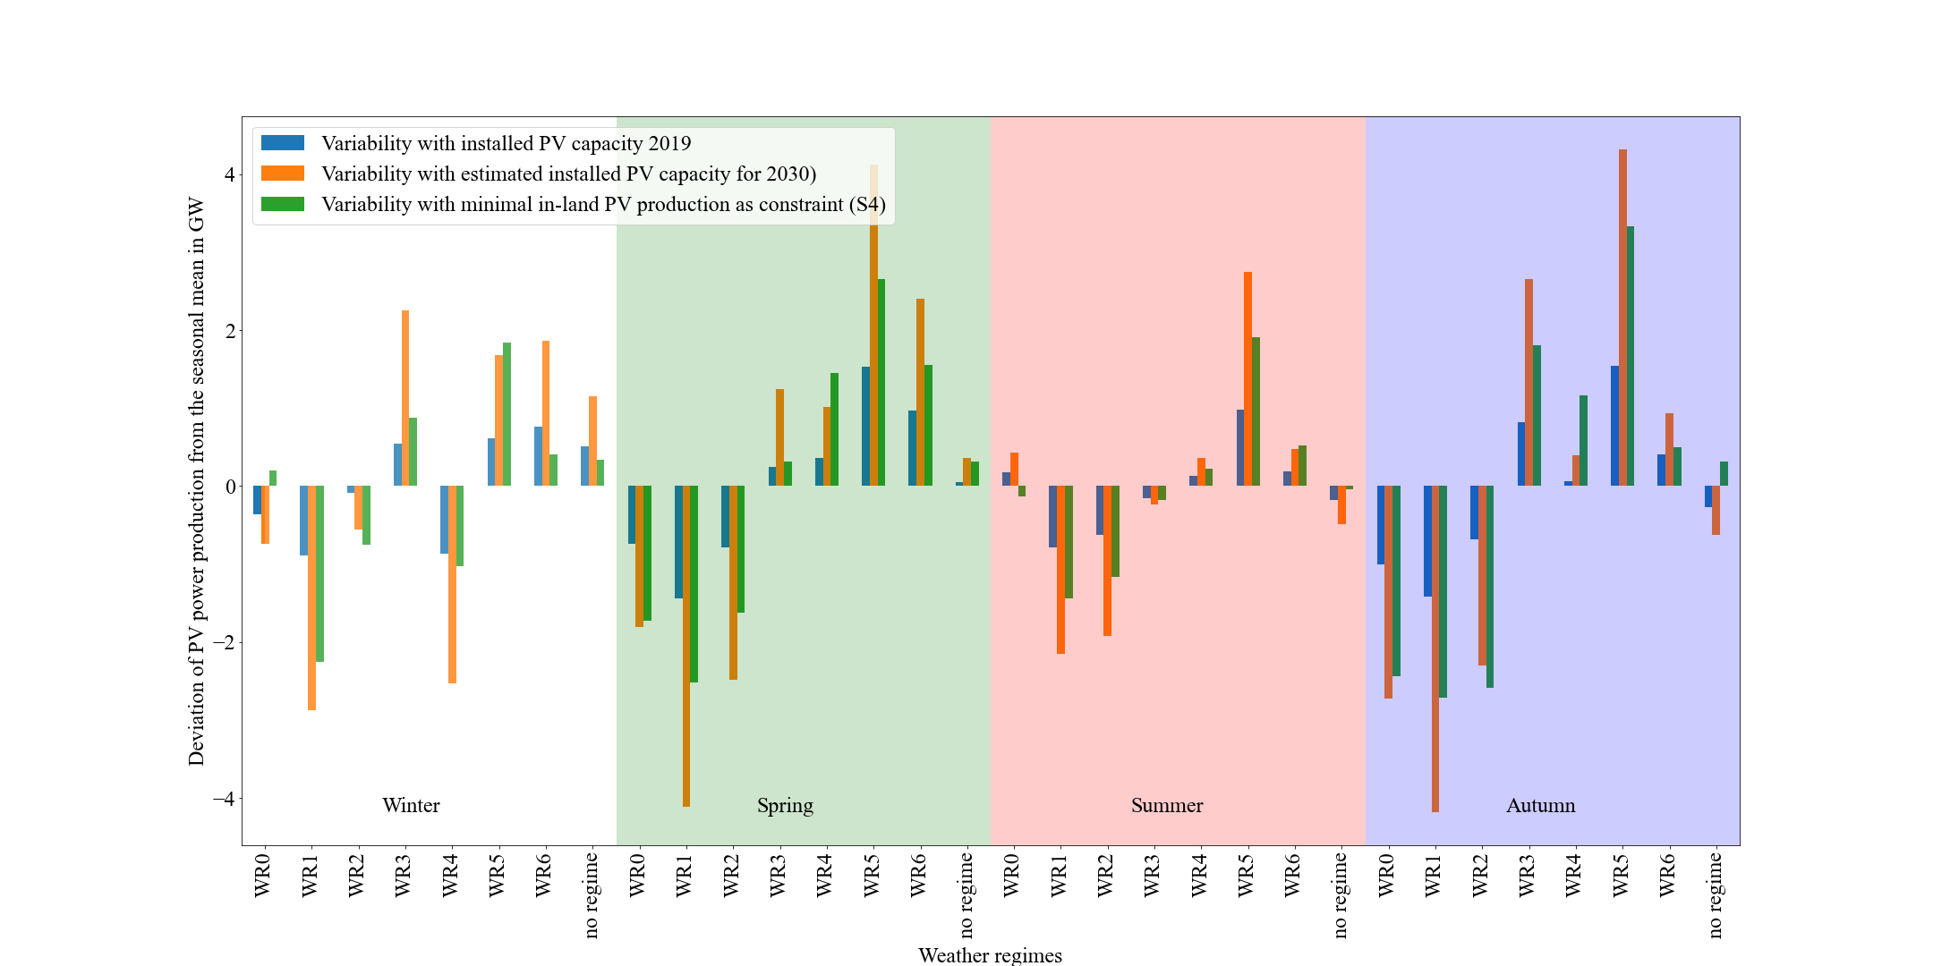

Figure : Deviation of the PV power production from the seasonal mean per weather regime and season. In blue the variability for the current situation (2019), in orange the estimated variability with the planned installed capacities for the year 2030 (NECPs) and in green the estimated variability with the installed capacity distribution for scenario 4-1.

Figure : Mean (bars) and maximum (black markers) consolidated (over all weather regimes) variability per season and overall (total). In blue the variability for the current situation (2019), in orange the estimated variability with the planned installed capacities for the year 2030 (NECPs) and in green the estimated variability with the installed capacity distribution for scenario 4-1.

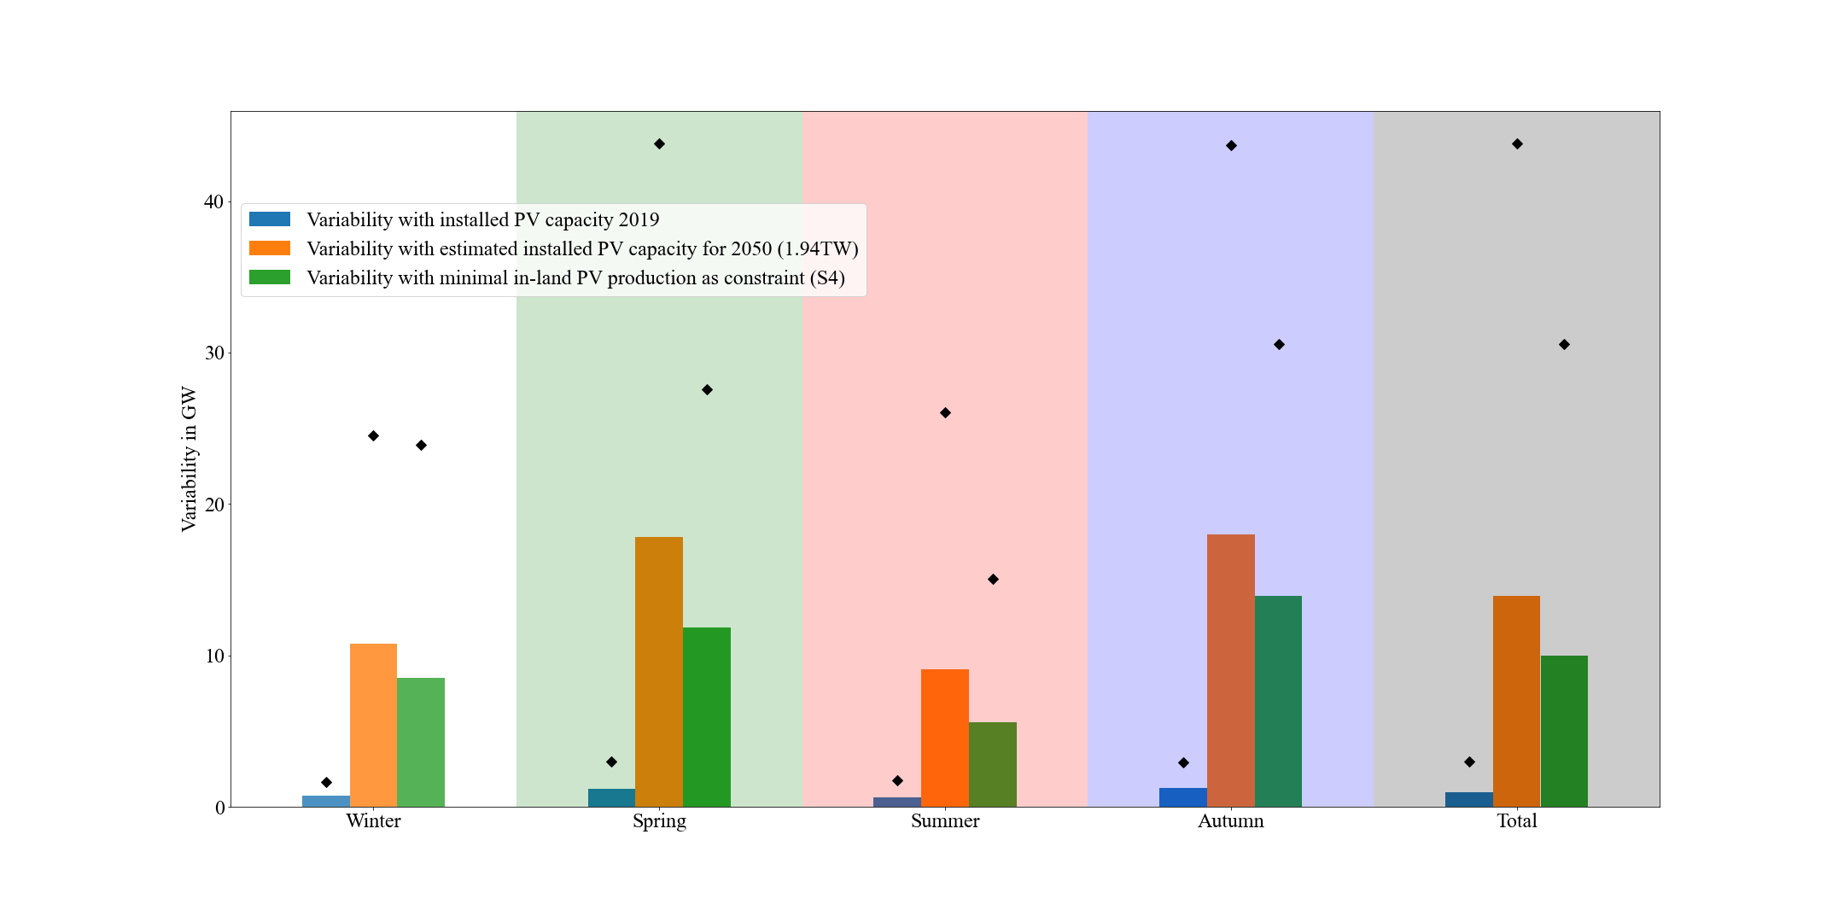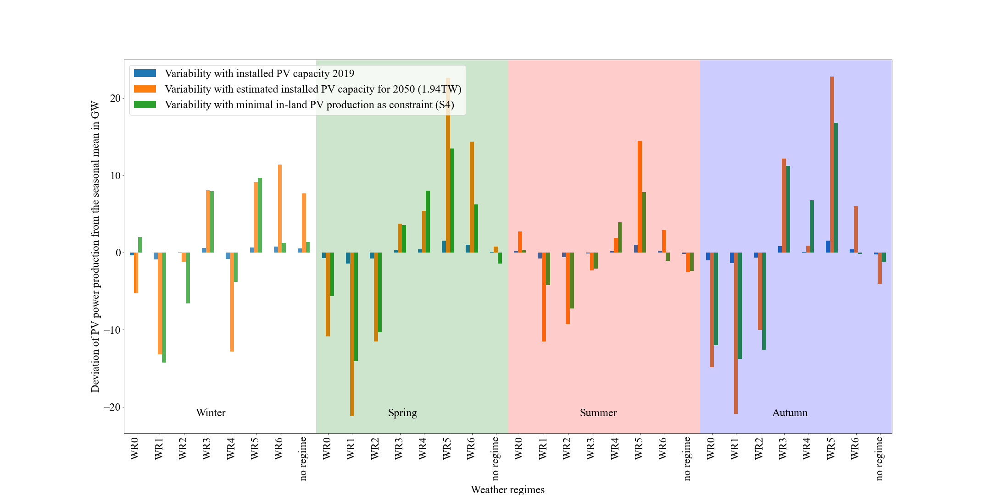

Figure : Deviation of the PV power production from the seasonal mean per weather regime and season. In blue the variability for the current situation (2019), in orange the estimated variability with the upscaled installed capacities to the year 2050 (1.94 TW) and in green the estimated variability with the installed capacity distribution for scenario 4-2.

Figure : Mean (bars) and maximum (black markers) consolidated (over all weather regimes) variability per season and overall (total). In blue the variability for the current situation (2019), in orange the estimated variability with the upscaled installed capacities to the year 2050 (1.94 TW) and in green the estimated variability with the installed capacity distribution for scenario 4-2.

# References

Amajama, J. (2016). Effect of Air Pressure on the Output of Photovoltaic Panel and Solar Illuminance ( or Intensity ). *International Journal of Scientific Engineering and Applied Science*, *2*(8), 139–144.

Baur, F., Hess, P., & Nagel, H. (1944). *Kalender der Großwetterlagen Europas 1881–1939*.

Bloomfield, H. C., Brayshaw, D. J., & Charlton-Perez, A. J. (2020). Characterizing the winter meteorological drivers of the European electricity system using targeted circulation types. *Meteorological Applications*, *27*(1), 1–18. https://doi.org/10.1002/met.1858

Branch, M. A., Coleman, T. F., & Li, Y. (1999). Subspace, interior, and conjugate gradient method for large-scale bound-constrained minimization problems. *SIAM Journal of Scientific Computing*, *21*(1), 1–23. https://doi.org/10.1137/S1064827595289108

Brayshaw, D. J., Troccoli, A., Fordham, R., & Methven, J. (2011). The impact of large scale atmospheric circulation patterns on wind power generation and its potential predictability: A case study over the UK. *Renewable Energy*, *36*(8), 2087–2096. https://doi.org/10.1016/j.renene.2011.01.025

Bremen, L. Von. (2010). Large-Scale Variability of Weather Dependent Renewable Energy Sources. In A. Troccoli (Ed.), *Management of Weather and Climate Risk in the Energy Industry* (pp. 189–206). Springer Netherlands.

Cassou, C. (2008). Intraseasonal interaction between the Madden-Julian Oscillation and the North Atlantic Oscillation. *Nature*, *455*(7212), 523–527. https://doi.org/10.1038/nature07286

Colantuono, G., Wang, Y., Hanna, E., & Erdélyi, R. (2014). Signature of the North Atlantic Oscillation on British solar radiation availability and PV potential: The winter zonal seesaw. *Solar Energy*, *107*, 210–219. https://doi.org/10.1016/j.solener.2014.05.045

Dawson, A. (2016). eofs: A Library for EOF Analysis of Meteorological, Oceanographic, and Climate Data. *Journal of Open Research Software*, *4*, 4–7. https://doi.org/10.5334/jors.122

Drücke, J., Borsche, M., James, P., Kaspar, F., Pfeifroth, U., Ahrens, B., & Trentmann, J. (2020). Climatological analysis of solar and wind energy in Germany using the Grosswetterlagen classification. *Renewable Energy*, *164*, 1254–1266. https://doi.org/10.1016/j.renene.2020.10.102

Ely, C. R., Brayshaw, D. J., Methven, J., Cox, J., & Pearce, O. (2013). Implications of the North Atlantic Oscillation for a UK-Norway Renewable power system. *Energy Policy*, *62*, 1420–1427. https://doi.org/10.1016/j.enpol.2013.06.037

Graabak, I., & Korpås, M. (2016). Variability Characteristics of European Wind and Solar Power Resources—A Review. *Energies*, *9*(6), 1–31. https://doi.org/10.3390/en9060449

Grams, C. M., Beerli, R., Pfenninger, S., Staffell, I., & Wernli, H. (2017). Balancing Europe’s wind-power output through spatial deployment informed by weather regimes. *Nature Climate Change*, *7*(8), 557–562. https://doi.org/10.1038/nclimate3338

Hennermann, K., & Yang, X. (2018). *ERA5 data documentation*. European Centre for Medium-Range Weather Forecasts. https://confluence.ecmwf.int/display/CKB/ERA5+data+documentation

Hersbach, H., Bell, B., Berrisford, P., Biavati, G., Horányi, A., Muñoz Sabater, J., Nicolas, J., Peubey, C., Radu, R., Rozum, I., Schepers, D., Simmons, A., Soci, C., Dee, D., & Thépaut, J.-N. (2018). *ERA5 hourly data on pressure levels from 1979 to present.* Copernicus Climate Change Service (C3S) Climate Data Store (CDS). https://doi.org/10.24381/cds.bd0915c6

Hirth, L., & Ziegenhagen, I. (2015). Balancing power and variable renewables: Three links. *Renewable and Sustainable Energy Reviews*, *50*(October 2015), 1035–1051. https://doi.org/10.1016/j.rser.2015.04.180

Huld, T., Gottschalg, R., Beyer, H. G., & Topič, M. (2010). Mapping the performance of PV modules, effects of module type and data averaging. *Solar Energy*, *84*(2), 324–338. https://doi.org/10.1016/j.solener.2009.12.002

Hulme, M. (2016). 1.5 °C and climate research after the Paris Agreement. *Nature Climate Change*, *6*(3), 222–224. https://doi.org/10.1038/nclimate2939

Hurrell, J. W., Kushnir, Y., Ottersen, G., & Visbeck, M. (2003). An overview of the north atlantic oscillation. *Geophysical Monograph Series*, *134*, 1–35. https://doi.org/10.1029/134GM01

IRENA. (2020a). Global Renewables Outlook: Energy transformation 2050. In *International Renewable Energy Agency*. https://www.irena.org/publications/2020/Apr/Global-Renewables-Outlook-2020

IRENA. (2020b). *Renewable capacity statistics 2020 International Renewable Energy Agency (IRENA)*.

Jäger-Waldau, A. (2019). PV Status Report 2019. In *EUR 29938 EN, Publications Office of the European Union*. https://doi.org/10.2760/326629

Jerez, S., Trigo, R. M., Vicente-Serrano, S. M., Pozo-VáZquez, D., Lorente-Plazas, R., Lorenzo-Lacruz, J., Santos-Alamillos, F., & MontáVez, J. P. (2013). The impact of the north atlantic oscillation on renewable energy resources in Southwestern Europe. *Journal of Applied Meteorology and Climatology*, *52*(10), 2204–2225. https://doi.org/10.1175/JAMC-D-12-0257.1

Jones, S., Lee, S. R., & Bloomfield, H. (2020). *Wintertime Impacts of Synoptic-Scale Weather Patterns on the European Energy Sector* (Issue August). University of Reading.

Lauret, P., Boland, J., & Ridley, B. (2013). Bayesian statistical analysis applied to solar radiation modelling. *Renewable Energy*, *49*, 124–127. https://doi.org/10.1016/j.renene.2012.01.049

Michelangeli, P. A., Vautard, R., & Legras, B. (1995). Weather regimes: recurrence and quasi stationarity. In *Journal of the Atmospheric Sciences* (Vol. 52, Issue 8, pp. 1237–1256). https://doi.org/10.1175/1520-0469(1995)052<1237:WRRAQS>2.0.CO;2

Muñoz Sabater, J. (2019). *ERA5-Land hourly data from 1981 to present.* Copernicus Climate Change Service (C3S) Climate Data Store (CDS). https://doi.org/10.24381/cds.e2161bac

Pedregosa, F., Varoquaux, G., Gramfort, A., Michel, V., Thirion, B., Grisel, O., Blondel, M., Prettenhofer, P., Weiss, R., Dubourg, V., Vanderplas, J., Passos, A., Cournapeau, D., Brucher, M., Perrot, M., & Duchesnay, E. (2011). Scikit-learn: Machine Learning in {P}ython. *Journal of Machine Learning Research*, *12*, 2825–2830.

Pfenninger, S., & Staffell, I. (2016). Long-term patterns of European PV output using 30 years of validated hourly reanalysis and satellite data. *Energy*, *114*, 1251–1265. https://doi.org/10.1016/j.energy.2016.08.060

Pozo-Vazquez, D., Santos-Alamillos, F. J., Lara-Fanego, V., Ruiz-Arias, J. A., & Tovar-Pescador, J. (2011). Hydrological, Socioeconomic and Ecological Impacts of the North Atlantic Oscillation in the Mediterranean Region. In *Hydrological, Socioeconomic and Ecological Impacts of the North Atlantic Oscillation in the Mediterranean Region* (Vol. 46, Issue December 2015). https://doi.org/10.1007/978-94-007-1372-7

Pozo-Vázquez, D., Tovar-Pescador, J., Gámiz-Fortis, S. R., Esteban-Parra, M. J., & Castro-Díez, Y. (2004). NAO and solar radiation variability in the European North Atlantic region. *Geophysical Research Letters*, *31*(5), n/a-n/a. https://doi.org/10.1029/2003gl018502

Ram, M., Bogdanov, D., Aghahosseini, A., Oyewo, S., Gulagi, A., Child, M., & Breyer, C. (2017). Global Energy System based on 100% Renewable Energy – Power Sector. *LUT Scientific and Expertise Publications : Raportit Ja Selvitykset - Reports*.

Ridley, B., Boland, J., & Lauret, P. (2010). Modelling of diffuse solar fraction with multiple predictors. *Renewable Energy*, *35*(2), 478–483. https://doi.org/10.1016/j.renene.2009.07.018

Rogers, J. C. (1997). North Atlantic storm track variability and its association to the North Atlantic oscillation and climate variability of Northern Europe. *Journal of Climate*, *10*(7), 1635–1647. https://doi.org/10.1175/1520-0442(1997)010<1635:NASTVA>2.0.CO;2

SolarPower Europe and LUT University. (2020). *100% Renewable Europe - How to make Europe’s energy system climate-neutral before 2050*. 64.

Stram, B. N. (2016). Key challenges to expanding renewable energy. *Energy Policy*, *96*, 728–734. https://doi.org/10.1016/j.enpol.2016.05.034

Tröndle, T., Pfenninger, S., & Lilliestam, J. (2019). Home-made or imported: On the possibility for renewable electricity autarky on all scales in Europe. *Energy Strategy Reviews*, *26*(June), 100388. https://doi.org/10.1016/j.esr.2019.100388

van der Wiel, K., Bloomfield, H. C., Lee, R. W., Stoop, L. P., Blackport, R., Screen, J. A., & Selten, F. M. (2019). The influence of weather regimes on European renewable energy production and demand. *Environmental Research Letters*, *14*(9), 094010. https://doi.org/10.1088/1748-9326/ab38d3

Vautard, R. (1990). Multiple weather regimes over the North Atlantic: analysis of precursors and successors. *Monthly Weather Review*, *118*(10). https://doi.org/10.1175/1520-0493(1990)118<2056:MWROTN>2.0.CO;2

Wallace, J. M., & Hobbs, P. V. (2006). *Atmospheric Science: An Introductory Survey* (2nd ed.). Amsterdam ; Boston : Elsevier Academic Press, [2006].